Supplementary Materials

Navigating Intersectional Expectations: A Computational Multimodal Analysis of the Effects of Identities and Communication Styles on Public Engagement with Science on TikTok

Submitted to Information, Communication, & Society

Table of Contents
Appendix A: Training a BERT model to identify science videos 4
Figure A1. The webpage for instructions 5
Figure A2. The visualized annotation webpage 6
Figure A3. The distribution of science and non-science videos in the sample videos for annotation. We treated a video as science-related if two or three annotators labeled it as such. 6
Appendix B: The distribution of face presence, genders, and racial groups 7
Figure B1. Distribution of face presence in science-related video cover images 7
Figure B2. Distribution of men, women, and NA(no face presence) in science-related video cover images. 8
Figure B3. Distribution of races in science-related video cover images 8
Figure B4. Sample video cover images (N=93) were identified as showing a real person who appears to be the video’s host. 9
Figure B5. Sample video cover images (N=7) were identified as animations, thirty-party news clips, or irrelevant entities. 9
Appendix C: The measurements and human validation of communication styles 10
Table C1. Finalized GPT prompt for identifying the Use of verbal aggressiveness. 12
Table C2. Example cases for informal and formal probability scores generated by the RoBERTa-base Formality Ranker model. 13
Figure C2. The Pearson’s correlation plot between the the overall affective tone scores produced by the RoBERTa-base model fine-tuned for sentiment analysis and LIWC-22 15
Figure C3. The Pearson’s correlation plot between the the overall affective tone score (summed by the negative and positive emotion scores), negative emotion, positive emotion, and neutral emotion scores produced by the RoBERTa-base model fine-tuned for sentiment analysis. 15
Figure C4. The distribution of the overall affective tone scores by gender. 16
Figure C5. The distribution of verbal aggressiveness by gender. 16
Figure C6. The distribution of informality and formality by racial groups. 17
Appendix D: Using large language models to identify the scientific discipline of videos 17
Table D1. Finalized GPT prompt for classifying scientific disciplines 18
Appendix E: The data distribution of outcome variables 20
Figure E1. The over-dispersed distribution with excessive zeros of response variables: number of shares, views, likes, and comments. 20
Appendix F: Robustness check 1 – removing videos containing multiple faces 21
Table F1. Main effects only (using public engagement as outcome variables). 21
Table F2. Interaction effects (using public engagement as outcome variables). 22
Table F3. Main and interaction effects (using the toxicity of comments as outcome variables) 24
Appendix G: Robustness check 2 – removing videos without receiving any comments 26
Table G1. Main effects only (using public engagement as outcome variables). 26
Table G2. Interaction effects (using public engagement as outcome variables). 27
Table G3. Main and interaction effects (using the toxicity of comments as outcome variables). 30
Appendix H: Robustness check 3 – using videos that did not genuinely talk about science 32
Table H1. Main effects only (using public engagement as outcome variables). 32
Table H2. Interaction effects (using public engagement as outcome variables). 33
Appendix I: Robustness check 4 – examining the effects of face presence 36
Table I1. Main effects only (using public engagement as outcome variables). 36
Appendix J: Robustness check 5 – examining the interaction effects between identities and scientific disciplines 37
Table J1. Interaction effects only (using public engagement as outcome variables). 37
Reference 40

Appendix A: Training a BERT model to identify science videos
To ensure the sample videos were truly focused on science, we recruited participants from Prolific to label 1,000 sample videos as either science or non-science videos. Using this crowdsourced data, we then trained a BERT-based machine learning model to identify true science videos.
As defined by Burns et al. (2003) and Welbourne and Grant (2016), science-related content falls into several categories:
1) Experience: sharing positive or negative experiences/responses/personal stories related to science;
2) Interest: voluntary involvement with science or its communication;
3) Opinions: the forming, reforming, or confirming of science-related attitudes. Opinions can be either pro-science or anti-science;
4) Understanding/knowledge: presenting science-related content, processes, and social factors.
We used Potato (Pei et al., 2022), a portable text annotation tool, to construct a visualized webpage interface and recruited participants from Prolific to annotate 1,000 videos that were randomly selected from our initial sample set. As Figures A1 and A2 illustrate, after reading the instructions, annotators were first presented with a video’s description and its audio transcript. These videos were originally from TikTok, but annotators did not watch the actual videos, only their descriptions and transcripts. Based on the video description and audio transcript we provided, their task was to judge whether the main content of the video could be categorized as science-related or not.
Each annotator was presented with 20 videos and asked to label each video as either science or non-science. Each video was annotated by three participants. We recruited 50 participants each round and had three rounds of annotation tasks in total. Following the common practice in treatment of crowd labels, we treated a video as science-related if two or all of the annotators labeled it as such (Park et al., 2023). As Figure A3 shows, there were 641 science-related videos and 351 non-science videos.
Then, we used the crowdsourced annotated science and non-science video dataset to train the BERT-based machine learning model, and got a model with high accuracy (.82, Precision .83, Recall .82, F1 .83). We then used the BERT model to categorize the videos in our sample. As a result, 21,617 videos were classified as science-related, while 11,558 videos were categorized as non-science and subsequently removed from the sample set. To validate this approach, an expert independently coded a random sample of 200 videos, yielding a Krippendorff’s alpha of 0.75.

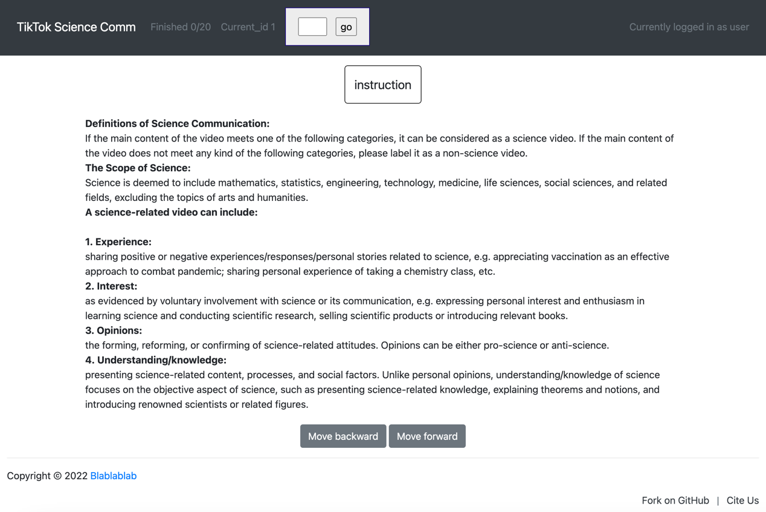

Figure A1. The webpage for instructions

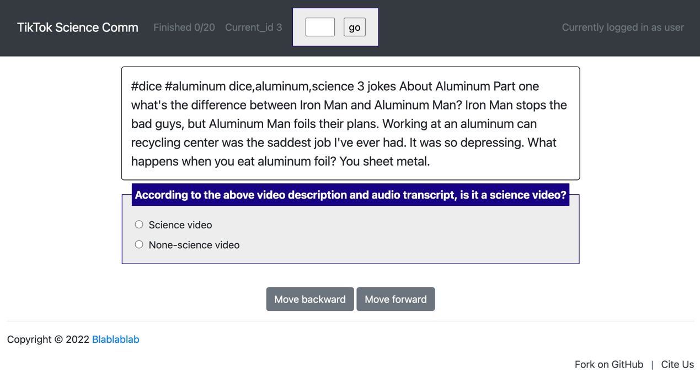

Figure A2. The visualized annotation webpage

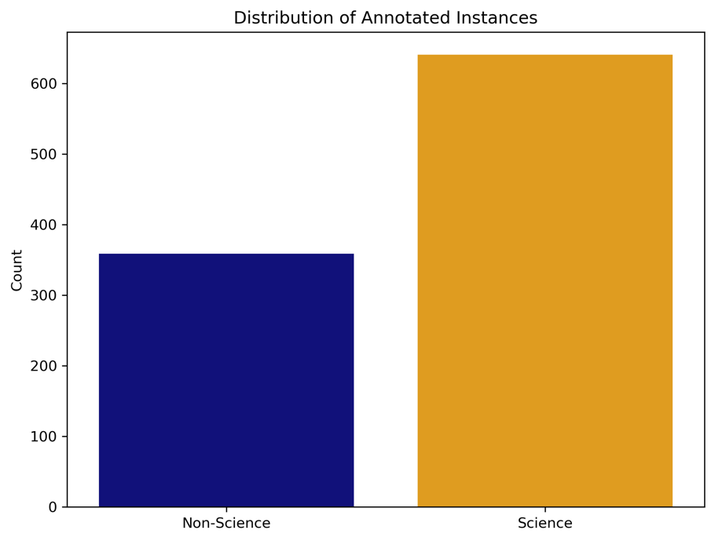

Figure A3. The distribution of science and non-science videos in the sample videos for annotation. We treated a video as science-related if two or three annotators labeled it as such.

Appendix B: The distribution of face presence, genders, and racial groups
As Figure B1 shows, based on the results estimated by DeepFace, 12,566 images (58.13%) contained identifiable faces, while 9,051 images (41.87%) did not.
Figure B2 shows that among the images with faces, 9,074 images were identified as male (72.21%) and 3,492 as female (27.79%). The racial distribution of these images is displayed in Figure B3. Specifically, 8,540 images were White (67.96%), 900 were Asian (7.16%), 831 were Black (6.61%), 171 were Indian (South Asian) (1.36%), 360 were Latino/Hispanic (2.86%), and 1,764 images were Middle Eastern (14.04%).
To ensure that our analysis focused on videos featuring real individuals serving as science communicators, we recruited a human expert to annotate a random sample of 100 video cover images. This expert evaluated whether each video featured a real person who appears to be hosting or speaking, as opposed to other formats such as animations, voiceovers, or third-party news clips. Among the 100 sampled videos, 93 were confirmed to feature an actual person as the primary communicator, and 7 cover images were identified as animations or irrelevant entities. We listed several sample cover images that were identified video hosts or non-video hosts.
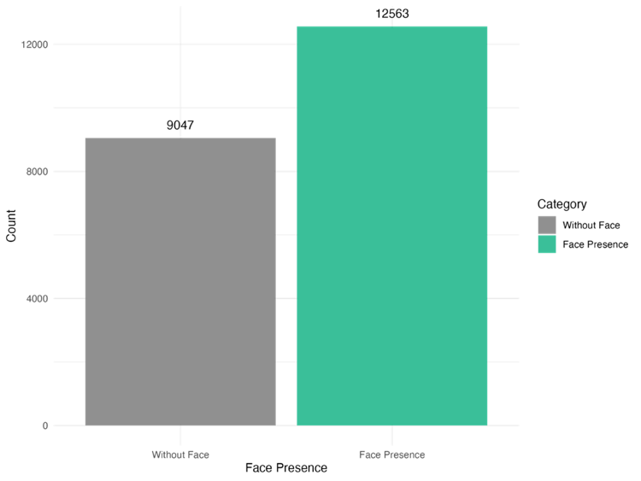

Figure B1. Distribution of face presence in science-related video cover images

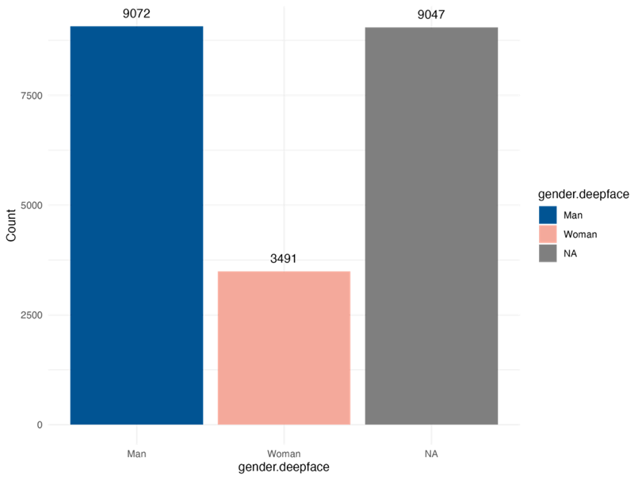

Figure B2. Distribution of men, women, and NA(no face presence) in science-related video cover images.

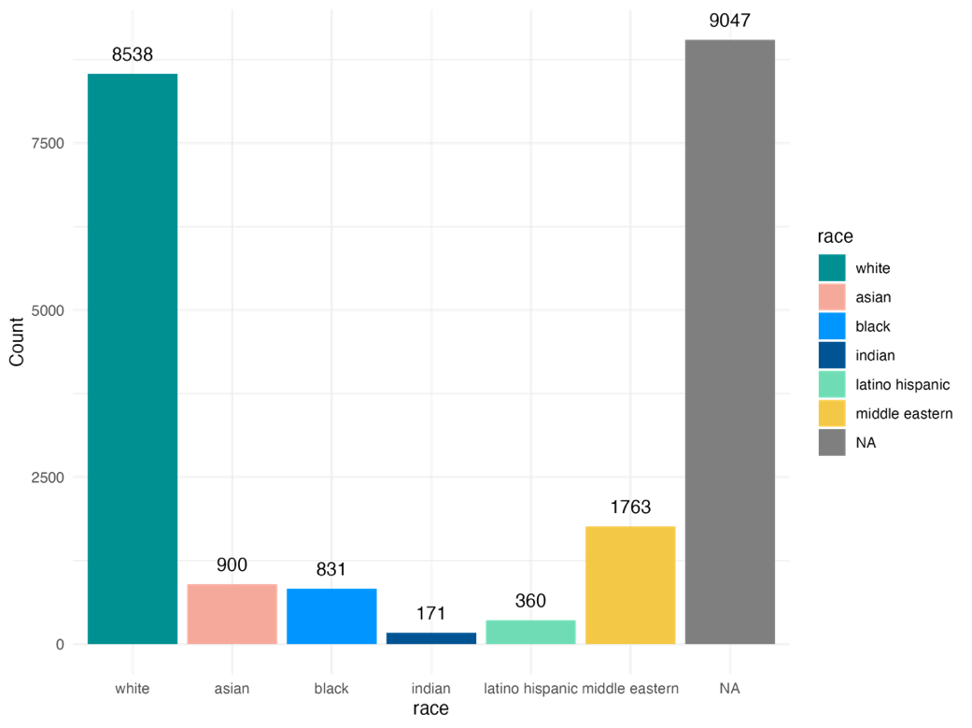

Figure B3. Distribution of races in science-related video cover images

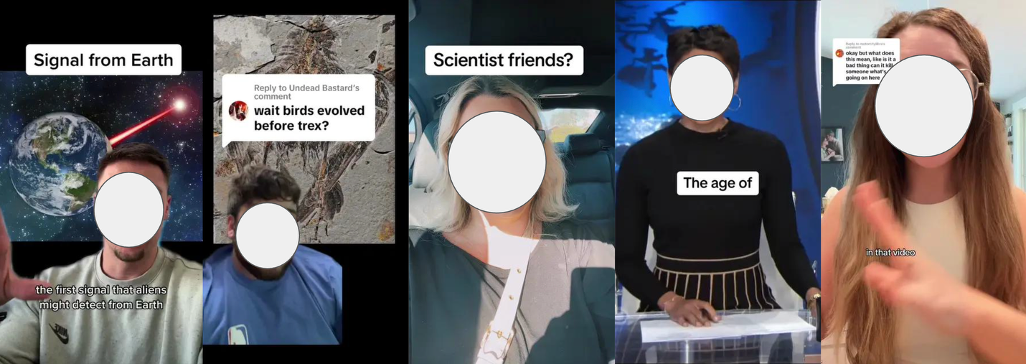

Figure B4. Sample video cover images (N=93) were identified as showing a real person who appears to be the video’s host.

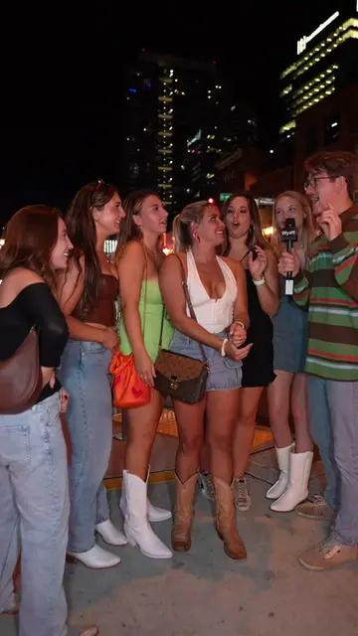

Figure B5. Sample video cover images (N=7) were identified as animations, thirty-party news clips, or irrelevant entities.

Appendix C: The measurements and human validation of communication styles
We relied on GPT-4o-mini to classify verbal aggressiveness on a binary scale, where 1 indicated the presence of verbal aggressiveness and 0 indicated its absence. Verbal aggressiveness was defined based on whether a video’s description and audio transcript contained any of the following four facets: (1) anger, (2) authoritarianism, (3) derogatory language, or (4) non-supportiveness (De Vries et al., 2013; see Appendix C for the detailed GPT prompt). Videos containing any of these facets were classified as verbally aggressive; otherwise, they were labeled as non-verbally aggressive.
Regarding the prompting strategy, we chose to use one-shot prompting rather than few-shot prompting for two reasons. First, drawing on literature (De Vries et al., 2013), we already have clear definitions of verbal aggressiveness, which enabled the LLM to perform reliably without additional examples. Second, few-shot prompting might introduce more variation in outputs depending on the examples used. Given the highly variable nature of social media messages and the multi-faced nature of the defined verbal aggressiveness, a few examples might not exhaustively capture verbal aggression on TikTok. To get a more efficient and consistent examination of verbal aggressiveness, we used one-shot prompting at the end. Using this approach, GPT-4o-mini identified 766 videos as verbally aggressive and 10,034 as non-verbally aggressive. To validate the classification, we randomly sampled 200 videos and had an expert coder independently annotate them. The inter-coder reliability between GPT-4o-mini and the expert coder was moderately high (Krippendorff’s alpha = .72; percent agreement = 87%).
To measure the overall affective tone, we used a RoBERTa-base model fine-tuned for sentiment analysis using the TweetEval benchmark. This model has been widely used in prior research and has demonstrated reliable performance across various social media platforms (Camacho-Collados et al., 2022). We applied the model to analyze the sentiment of each video’s description and audio transcript, generating three sentiment scores—positive, negative, and neutral—that together sum to 1. To quantify the overall emotional intensity, we calculated the overall affective tone as the combined score of positive and negative sentiment, capturing the strength of emotional expression regardless of its valence. To assess the model’s reliability, we computed the Pearson correlation between its output and the results produced by Linguistic Inquiry and Word Count (LIWC-22). We calculated the percentage of affective words indicating positive and negative tones within a video’s description and audio transcript using the Linguistic Inquiry and Word Count (LIWC) dictionary. The correlation coefficient was .30, indicating a moderate level of agreement and offering preliminary validation of the model’s effectiveness.
We measured informality by evaluating whether a video’s description and transcript exhibited casual, personal, and relaxed communication styles (De Vries et al., 2013), such as the use of informal language, a casual tone, and direct personal engagement with the audience. To determine if a science video uses an informal communication style, we employed a RoBERTa-base Formality Ranker model (Babakov et al., 2023). This model, trained on Grammarly’s Yahoo Answers Formality Corpus and an online formality corpus, predicts two probability scores (ranging from 0 to 1): one for formality and one for informality, performing well across various topics and domains (Pavlick & Tetreault, 2016).
This BERT model is optimized to distinguish which text is more formal or more informal in relative terms, rather than to assign an absolute “formal vs. informal” label. The relative ordering of the formality and informality scores is the most meaningful information given by the rank-based design. We thus classified a video as informal if its informality score exceeded its formality score, which aligns with the model’s rank-based design. Based on this criterion, 6,547 videos were classified as informal and 4,253 as formal. A trained expert independently coded a random sample of 200 videos, showing good performance metrics (F1 = 0.88, Recall = 0.84, Precision = 0.92) and a Krippendorff’s alpha of .75.

Table C1. Finalized GPT prompt for identifying the Use of verbal aggressiveness.

Prompt for Identifying the Use of Verbal Aggressiveness
Please carefully analyze the TikTok video’s description and audio transcript. Your task is to classify the video’s content based on the following definition of verbal aggressiveness:
Verbal aggressiveness is a style of language characterized by any of the following four facets:
- Angriness: Communicating with anger or irritation.
- Authoritarianism: Displaying a domineering or controlling communication style.
- Derogatoriness: Using demeaning language towards others.
- Nonsupportiveness: Exhibiting a lack of empathy or support in language.
If a given text contains any of these facets, classify the video as verbal aggressiveness (1). Otherwise, classify it as not verbal aggressiveness (0). Output only the classification (1 or 0), without any explanation.
The video’s description and audio transcript are provided below: {text}

Table C2. Example cases for informal and formal probability scores generated by the RoBERTa-base Formality Ranker model.

Text | Informality prob (model) | Formality prob (model) | Label ranked by the model | Human label
part 1 || people vs climate change #science #fyp #foryoupage❤️❤️ uh you believe in climate change yes uh what do you why there's a lot of scientific evidence to support it do you know any deniers yes what's their reasoning there is not a lot of scientific evidence to support it ha ha scientists have been very wishy bossy these days ah people believing in it yeah it's been all over the place yeah what are you taking any steps to to help with climate change reusable straws okay thank you have a good one you believe in climate change I do do you know anyone that uh denies it um not personally no how do you know it's real I mean I would say I just generally trust um scientists who have said it I'm same right I mean I would say I can't I can't like say that I know with 100% certainty but I think that's most likely real what are you doing to help you know honestly not enough um you know I try to make small everyday decisions… | 0.9113532305 | 0.08864674717 | Informal | Informal
WOW! Are you ready for the #ringoffire #eclipse? #solareclipse #california #nevada #elko #albuquerque #newmexico #arizona #texas #colombia #mexico #yucatan #panama #brazil #astronomy #science #space #sun #moon On Saturday, October 14th, the sun will turn into a ring of fire. It's thanks to an angular solar eclipse where the moon blocks the sun. You'll see the ring of fire in a path of angularity across the southwest US. Cities like Elco, Nevada, Santa Fe in Albuquerque, New Mexico, and San Antonio and Corpus Christi, Texas, will be right in that zone. And those folks will see about four and a half minutes of full annularity… | 0.7110382915 | 0.2889616489 | Informal | Informal
#knowledge #fyp #science What does it feel like to be hit by a gun? If you think that pain will occur instantly, then you have really been deceived by the movie. According to the description of the survivor after being shot, the moment he was shot didn't feel any pain. On the contrary, it seems like there is a force rushed into his own body. Then a numbness started. Gradually spread from the affected area to the whole body. After the numbness and fear disappear, will produce pain. And some people have reached the stage. Only then did I realize that I had actually been shot. What the hell is going on? Logically speaking, high temperature metal bullets rotating at high speed should instantly destroy your skin and nerves. And it will make you feel intense pain right away. And the reason why there is no immediate pain? … | 0.003974421415 | 0.9960255623 | Formal | Formal
Dirty Talk-Hila The Planet #foryoupage #earth #flerfearf #flatearthdebunked #science #fyp #hilatheearth Talk Dirty. I Give You the Sound. Give Me the Roots. I Give You the mouth. Give Me Your Feces. We need to Hustle. Clean Up My Beaches. Show Me Your Muscles. I'll Give You Crabs. I'll Give You Turtles. Fill Me Up, Baby. I'm Building Them for dirty talk. You dirt. Feeling the clay of the sand up my shirt, slipping myself. I'll give you a squirt. You want to eat it? You need my dirt as a vitamin. Spread your seeds. I am vitamin. Giving you what you need time and time again. I got minerals, fungi, H 2 O, bacteria, carbon, nematons. Wanna grow? You gotta get a hoe. Go work the lamb. That's a hand job, bro. For your organics all over my body. I'll make it hot. Welcome to watch. I'll make it down, I'll listen all up. And then when I'm done, you keep watching me. Stop breaking up that password. I'm sequestering that carbon. I come alive when you get me wet. There's an orgy in your garden… | 0.4114659727 | 0.5885340571 | Formal | Informal

Figure C2. The Pearson’s correlation plot between the the overall affective tone scores produced by the RoBERTa-base model fine-tuned for sentiment analysis and LIWC-22
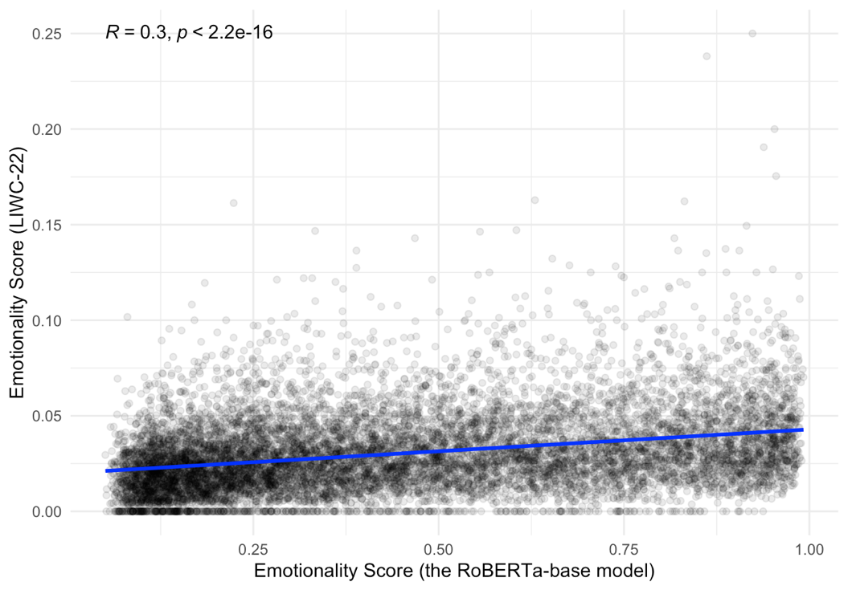

Figure C3. The Pearson’s correlation plot between the the overall affective tone score (summed by the negative and positive emotion scores), negative emotion, positive emotion, and neutral emotion scores produced by the RoBERTa-base model fine-tuned for sentiment analysis.
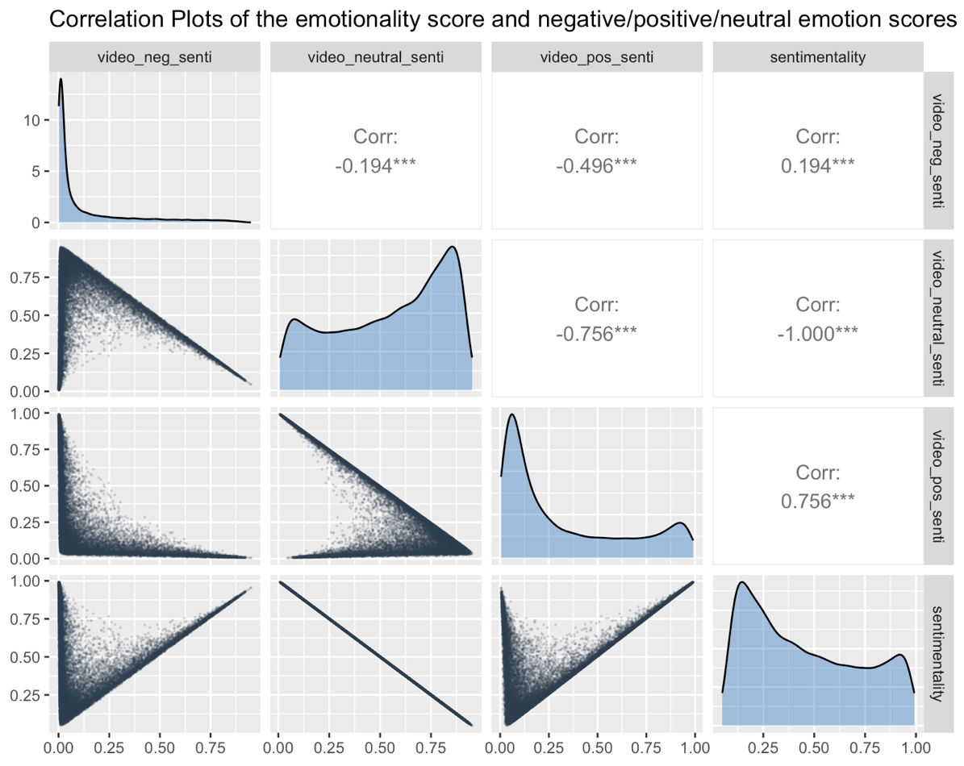

Figure C4. The distribution of the overall affective tone scores by gender.

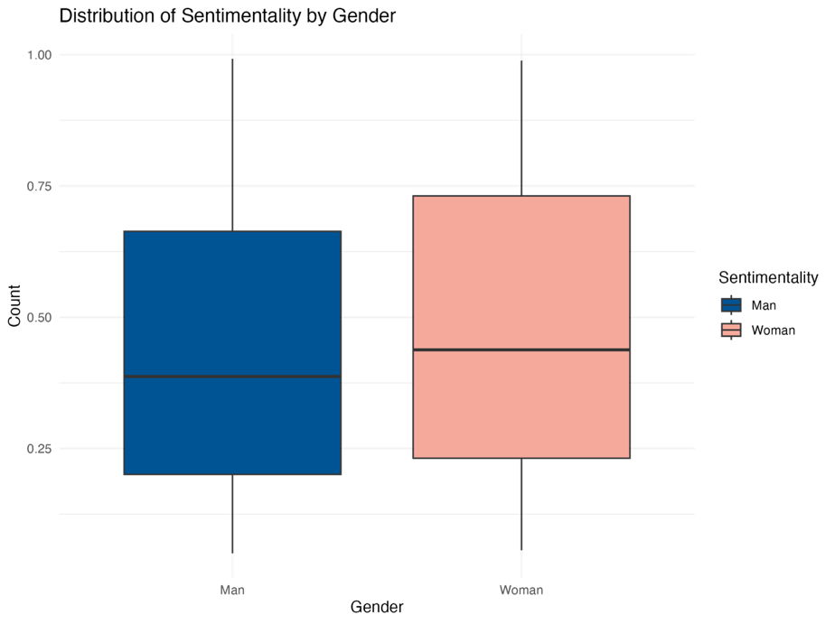

Figure C5. The distribution of verbal aggressiveness by gender.

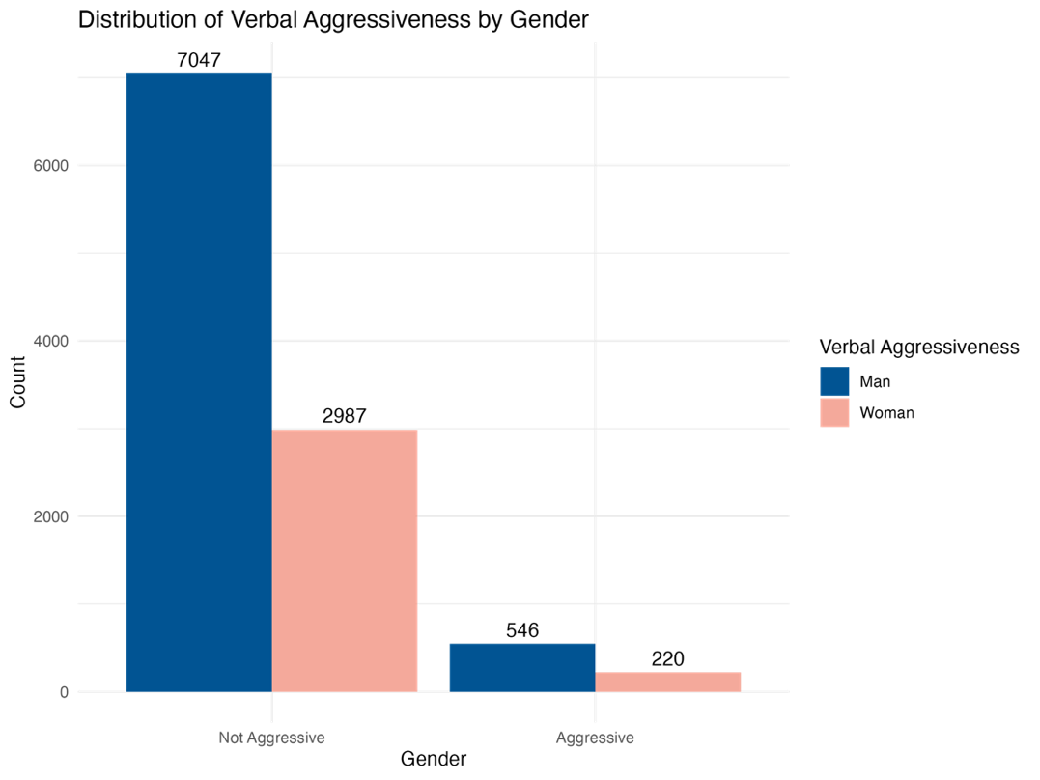

Figure C6. The distribution of informality and formality by racial groups.

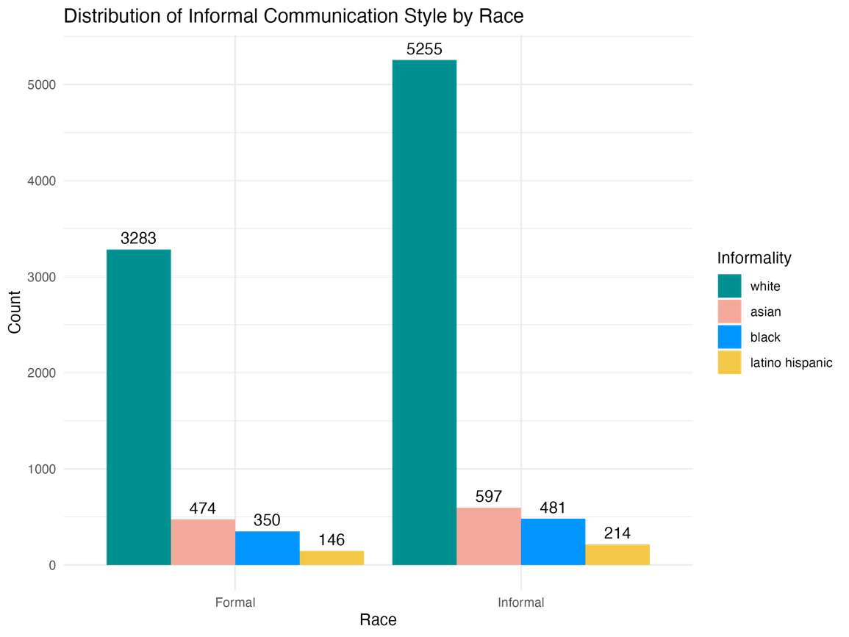

Appendix D: Using large language models to identify the scientific discipline of videos
We used a state-of-the-art large language model, GPT-4o-mini, to classify the scientific discipline of each video into one of seven categories: engineering (mechanical engineering, electronic engineering, robotics, etc.), computer science (computer science, information systems, software engineering, data science, etc.), physical science (physics, astronomy, chemistry, earth sciences, etc.), formal science (mathematics, statistics, logic, etc.), life and health-related science (biology, medicine, public health, ecology, etc.), social science (psychology, sociology, political science, economics, business, communication, etc.), and humanities and arts (history, philosophy, anthropology, arts, etc.). While the classification of scientific disciplines remains a topic of ongoing debate, our framework closely aligns with the Fields of Science and Technology (FOS) classification developed by the OECD. After conducting several pilot tests on classification tasks, we found that this categorization effectively captured the scientific topics commonly discussed on social media platforms. As a result, we adopted this classification scheme for our study. The prompt we used for the classification task is shown in Table D1.
Among 10,800 videos in our dataset, there are 10,136 life and health-related science videos, 9,033 physical science videos, 1,264 engineering videos, 567 social science videos, 208 formal science videos, 204 humanities and arts videos, and 198 computer science videos. Based on prior studies on gender-science stereotypes and gender ratios across science disciplines (Smyth & Nosek, 2015), we classified engineering, computer science, and physical science as male-/White-dominated scientific disciplines, while life and health-related science, social science, and humanities and arts as more gender- and racially-diverse scientific disciplines.
To validate the classification, we randomly sampled 200 videos and had an expert coder manually categorize them. Krippendorff’s alpha between the model and the human coder was 0.65, with a percent agreement of 78%, indicating a reasonable level of reliability. We judged a Krippendorff’s alpha of 0.65 as “acceptable” for two reasons: 1) Scientific discipline is not a focal independent variable in our hypotheses or primary analyses; rather, it is used to describe the dataset and to control for broad topical differences across videos. 2) 0.65 is an acceptable performance for a seven-category annotation task. For context, a recent study using GPT to annotate “emotional support” on a binary scale reported a Krippendorff’s alpha of 0.69 (Zhao et al., 2024). It suggests that our reliability is comparable to other LLM-based annotation tasks, despite involving more categories.

Table D1. Finalized GPT prompt for classifying scientific disciplines

Prompt for Classiying Scientific Disciplines
Given the following TikTok video description and transcript, classify it into the most appropriate scientific category from the list below. Only return the name of the category that best fits the content of the video.
- Engineering: mechanical engineering, electronic engineering, robotics, etc.
- Computer science: computer science, information systems, software engineering, data science, etc.
- Physical science: physics, astronomy, chemistry, earth sciences etc.
- Formal science: mathematics, statistics, logic, etc.
- Life and health-related science: biology, medicine, public health, ecology, etc.
- Social science: psychology, sociology, political science, economics, business, communication, etc.
- Humanities and arts: history, philosophy, anthropology, arts, etc.
The TikTok video’s description and audio transcript are provided below: {text}

Appendix E: The data distribution of outcome variables

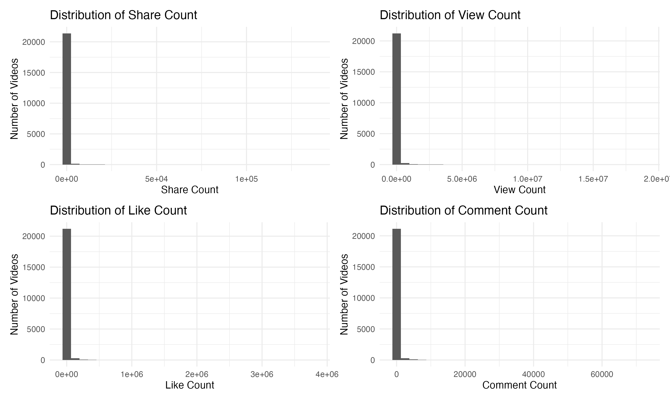

Figure E1. The over-dispersed distribution with excessive zeros of response variables: number of shares, views, likes, and comments.

Appendix F: Robustness check 1 – removing videos containing multiple faces

Table F1. Main effects only (using public engagement as outcome variables).
 | Shares count |  | Views count |  | Likes count |  | Comments count
Predictors | Estimates | std. Error | Estimates | std. Error | Estimates | std. Error | Estimates | std. Error
(Intercept) | −4.473 *** | 0.208 | 3.265 *** | 0.115 | 2.512 *** | 0.093 | 0.226 * | 0.100
Woman | −0.546 *** | 0.082 | −0.531 *** | 0.048 | −0.208 *** | 0.041 | −0.200 *** | 0.042
Asian | −0.081 | 0.120 | −0.291 *** | 0.071 | −0.253 *** | 0.063 | −0.213 *** | 0.063
Black | −1.096 *** | 0.138 | −0.712 *** | 0.081 | −0.516 *** | 0.071 | −0.109 | 0.073
Latino/Hispanic | 0.914 *** | 0.204 | −0.345 ** | 0.120 | −0.054 | 0.105 | 0.136 | 0.107
Verbal aggressiveness | 0.746 *** | 0.139 | 0.343 *** | 0.086 | 0.544 *** | 0.075 | 1.090 *** | 0.075
Informality | 0.258 *** | 0.076 | 0.322 *** | 0.046 | 0.371 *** | 0.039 | 0.182 *** | 0.039
The overall affective tone | 0.839 *** | 0.140 | 0.365 *** | 0.080 | 0.572 *** | 0.069 | 0.169 * | 0.070
Number of followers (log) | 1.019 *** | 0.021 | 0.764 *** | 0.010 | 0.745 *** | 0.010 | 0.599 *** | 0.010
Number of followings (log) | 0.030 | 0.018 | −0.180 *** | 0.012 | −0.040 *** | 0.010 | −0.012 | 0.009
Verified Status | 0.139 | 0.154 | 0.353 *** | 0.094 | 0.062 | 0.082 | −0.260 ** | 0.084
Number of historical videos (log) | −1.038 *** | 0.040 | −0.762 *** | 0.023 | −0.750 *** | 0.021 | −0.531 *** | 0.019
Number of published days | 0.010 *** | 0.000 | 0.010 *** | 0.000 | 0.006 *** | 0.000 | 0.004 *** | 0.000
science category [hard  science] | 0.679 *** | 0.079 | 0.783 *** | 0.044 | 0.617 *** | 0.039 | 0.385 *** | 0.040
Observations | 9428
* p<0.05 ** p<0.01 *** p<0.001

Table F2. Interaction effects (using public engagement as outcome variables).
 | Shares count |  | Views count |  | Likes count |  | Comments count
Predictors | Estimates | std. Error | Estimates | std. Error | Estimates | std. Error | Estimates | std. Error
(Intercept) | −3.928 *** | 0.215 | 3.628 *** | 0.121 | 2.799 *** | 0.100 | 0.296 ** | 0.105
Woman | −1.518 *** | 0.165 | −1.184 *** | 0.096 | −0.712 *** | 0.081 | −0.115 | 0.085
Asian | −1.399 *** | 0.227 | −1.159 *** | 0.121 | −0.692 *** | 0.113 | −0.391 *** | 0.112
Black | −1.858 *** | 0.211 | −0.692 *** | 0.124 | −0.649 *** | 0.110 | −0.426 *** | 0.112
Latino/Hispanic | −0.088 | 0.426 | −0.601 ** | 0.214 | −0.204 | 0.177 | −0.187 | 0.179
Verbal aggressiveness | 0.693 *** | 0.162 | 0.177 | 0.100 | 0.542 *** | 0.088 | 1.075 *** | 0.089
Informality | −0.142 | 0.085 | 0.182 *** | 0.052 | 0.241 *** | 0.045 | 0.118 ** | 0.044
Overall affective tone | 0.004 | 0.164 | −0.198 | 0.101 | 0.144 | 0.085 | 0.173 * | 0.086
Number of followers (log) | 1.032 *** | 0.021 | 0.772 *** | 0.010 | 0.745 *** | 0.010 | 0.600 *** | 0.010
Number of followings (log) | −0.002 | 0.019 | −0.189 *** | 0.012 | −0.046 *** | 0.010 | −0.010 | 0.009
Verified Status | 0.372 * | 0.159 | 0.466 *** | 0.094 | 0.122 | 0.083 | −0.286 *** | 0.085
Number of historical videos (log) | −1.046 *** | 0.040 | −0.763 *** | 0.023 | −0.746 *** | 0.020 | −0.539 *** | 0.019
Male-/White-dominated scientific disciplines | 0.583 *** | 0.077 | 0.752 *** | 0.044 | 0.594 *** | 0.039 | 0.372 *** | 0.040
Number of published days | 0.011 *** | 0.000 | 0.010 *** | 0.000 | 0.006 *** | 0.000 | 0.004 *** | 0.000
Woman × Asian | 0.629 * | 0.269 | 0.735 *** | 0.153 | 0.152 | 0.140 | 0.220 | 0.141
Woman × Black | 0.538 | 0.451 | 0.023 | 0.266 | 0.549 * | 0.233 | 0.328 | 0.239
Woman × Latino/Hispanic | −2.801 *** | 0.476 | −1.332 *** | 0.250 | −0.654 ** | 0.221 | −1.510 *** | 0.229
Woman × Verbal aggressiveness | −0.326 | 0.293 | 0.345 | 0.181 | −0.091 | 0.160 | 0.011 | 0.162
Asian × Informality | 1.692 *** | 0.262 | 0.914 *** | 0.146 | 0.653 *** | 0.132 | 0.188 | 0.132
Black × Informality | 1.106 *** | 0.270 | −0.052 | 0.164 | 0.093 | 0.143 | 0.454 ** | 0.146
Latino/Hispanic × Informality | 1.872 *** | 0.455 | 0.857 *** | 0.244 | 0.540 * | 0.215 | 0.943 *** | 0.222
Woman × Overall affective tone | 2.189 *** | 0.287 | 1.259 *** | 0.170 | 1.060 *** | 0.143 | −0.176 | 0.150
Observations | 9428
* p<0.05 ** p<0.01 *** p<0.001

Table F3. Main and interaction effects (using the toxicity of comments as outcome variables)
 | Comment toxicity |  | Comment toxicity
Predictors | Estimates | std. Error | Estimates | std. Error
(Intercept) | 0.095 *** | 0.002 | 0.093 *** | 0.002
Woman | −0.007 *** | 0.002 | −0.005 | 0.004
Asian | −0.000 | 0.003 | −0.001 | 0.004
Black | 0.004 | 0.003 | 0.008 | 0.005
Latino/Hispanic | 0.007 | 0.005 | 0.020 * | 0.008
Verbal aggressiveness | 0.036 *** | 0.003 | 0.035 *** | 0.004
Informality | 0.003 | 0.002 | 0.004 * | 0.002
Overall affective tone | 0.002 | 0.003 | 0.004 | 0.003
Male-/White-dominated scientific disciplines | −0.009 *** | 0.002 | −0.009 *** | 0.002
Woman × Asian |  |  | 0.000 | 0.006
Woman × Black |  |  | −0.004 | 0.010
Woman × Latino/Hispanic |  |  | 0.009 | 0.010
Woman × Verbal aggressiveness |  |  | 0.003 | 0.006
Asian × Informality |  |  | 0.001 | 0.005
Black × Informality |  |  | −0.006 | 0.006
Latino/Hispanic × Informality |  |  | −0.024 ** | 0.009
Woman × Overall affective tone |  |  | −0.005 | 0.006
Random Effects
σ² | 0.00 |  | 0.00
τ₀₀ | 0.00 _{Username} |  | 0.00 _{Username}
ICC | 0.37 |  | 0.37
N | 2881 _{Username} |  | 2881 _{Username}
Observations | 7118 |  | 7118
Marginal R² / Conditional R² | 0.028 / 0.383 |  | 0.029 / 0.384
* p<0.05 ** p<0.01 *** p<0.001

Appendix G: Robustness check 2 – removing videos without receiving any comments

Table G1. Main effects only (using public engagement as outcome variables).
 | Shares count |  | Views count |  | Likes count |  | Comments count
Predictors | Estimates | std. Error | Estimates | std. Error | Estimates | std. Error | Estimates | std. Error
(Intercept) | −3.583 *** | 0.211 | 3.775 *** | 0.121 | 3.005 *** | 0.098 | 0.930 *** | 0.094
Woman | −0.652 *** | 0.079 | −0.595 *** | 0.048 | −0.268 *** | 0.041 | −0.267 *** | 0.038
Asian | −0.113 | 0.113 | −0.113 | 0.070 | −0.303 *** | 0.061 | −0.197 *** | 0.057
Black | −0.933 *** | 0.129 | −0.477 *** | 0.079 | −0.467 *** | 0.069 | −0.087 | 0.065
Latino/Hispanic | 0.515 ** | 0.187 | −0.039 | 0.117 | −0.173 | 0.102 | 0.005 | 0.095
Verbal aggressiveness | 0.689 *** | 0.128 | 0.656 *** | 0.080 | 0.588 *** | 0.069 | 1.072 *** | 0.064
Informality | 0.191 ** | 0.072 | 0.181 *** | 0.046 | 0.326 *** | 0.039 | 0.135 *** | 0.036
Overall affective tone | 1.189 *** | 0.134 | 0.342 *** | 0.078 | 0.666 *** | 0.068 | 0.301 *** | 0.064
Number of followers (log) | 0.957 *** | 0.020 | 0.755 *** | 0.011 | 0.730 *** | 0.010 | 0.543 *** | 0.009
Number of followings (log) | −0.033 * | 0.017 | −0.152 *** | 0.011 | −0.044 *** | 0.010 | −0.034 *** | 0.008
Verified status | 0.094 | 0.143 | 0.376 *** | 0.088 | 0.114 | 0.078 | −0.182 * | 0.074
Number of historical videos (log) | −0.980 *** | 0.038 | −0.813 *** | 0.023 | −0.771 *** | 0.020 | −0.495 *** | 0.017
Number of published days | 0.010 *** | 0.000 | 0.010 *** | 0.000 | 0.006 *** | 0.000 | 0.004 *** | 0.000
Male-/White-dominated scientific disciplines | 0.526 *** | 0.076 | 0.749 *** | 0.044 | 0.583 *** | 0.039 | 0.309 *** | 0.036
Observations | 9753
* p<0.05 ** p<0.01 *** p<0.001

Table G2. Interaction effects (using public engagement as outcome variables).
 | Shares count |  | Views count |  | Likes count |  | Comments count
Predictors | Estimates | std. Error | Estimates | std. Error | Estimates | std. Error | Estimates | std. Error
(Intercept) | −3.025 *** | 0.233 | 3.984 *** | 0.132 | 3.211 *** | 0.109 | 0.915 *** | 0.103
Woman | −1.242 *** | 0.163 | −1.179 *** | 0.100 | −0.694 *** | 0.086 | −0.062 | 0.083
Asian | −0.617 ** | 0.194 | −0.323 ** | 0.114 | −0.515 *** | 0.107 | −0.224 * | 0.098
Black | −1.413 *** | 0.193 | −0.141 | 0.123 | −0.611 *** | 0.107 | −0.316 ** | 0.100
Latino/Hispanic | −0.134 | 0.401 | −0.356 | 0.224 | −0.340 * | 0.169 | −0.156 | 0.161
Male-/White-dominated scientific disciplines | 0.316 *** | 0.091 | 0.686 *** | 0.053 | 0.577 *** | 0.046 | 0.309 *** | 0.043
Verbal aggressiveness | 0.748 *** | 0.151 | 0.605 *** | 0.096 | 0.648 *** | 0.082 | 1.107 *** | 0.076
Informality | −0.045 | 0.081 | 0.158 ** | 0.051 | 0.252 *** | 0.045 | 0.110 ** | 0.040
Overall affective tone | 0.777 *** | 0.164 | −0.136 | 0.098 | 0.336 *** | 0.084 | 0.404 *** | 0.078
Number of followers (log) | 0.960 *** | 0.020 | 0.765 *** | 0.011 | 0.731 *** | 0.010 | 0.545 *** | 0.009
Number of followings (log) | −0.063 *** | 0.018 | −0.168 *** | 0.011 | −0.053 *** | 0.010 | −0.031 *** | 0.008
Verified status | 0.185 | 0.147 | 0.418 *** | 0.089 | 0.140 | 0.078 | −0.207 ** | 0.074
Number of historical videos (log) | −0.989 *** | 0.039 | −0.804 *** | 0.023 | −0.763 *** | 0.020 | −0.503 *** | 0.017
Number of published days | 0.010 *** | 0.000 | 0.009 *** | 0.000 | 0.006 *** | 0.000 | 0.003 *** | 0.000
Woman × Asian | 0.288 | 0.246 | 0.308 * | 0.153 | 0.091 | 0.137 | 0.156 | 0.127
Woman × Black | 0.536 | 0.407 | 0.189 | 0.258 | 1.031 *** | 0.225 | 0.257 | 0.210
Woman × Latino/Hispanic | −2.201 *** | 0.454 | −1.702 *** | 0.257 | −0.772 *** | 0.223 | −1.257 *** | 0.207
Woman × Male-/White-dominated scientific disciplines | 0.462 ** | 0.160 | 0.069 | 0.096 | −0.035 | 0.084 | −0.035 | 0.077
Woman × Verbal aggressiveness | −0.567 * | 0.277 | −0.182 | 0.174 | −0.291 | 0.152 | −0.110 | 0.142
Asian× Informality | 0.636 ** | 0.234 | 0.124 | 0.146 | 0.310 * | 0.128 | −0.024 | 0.118
Black× Informality | 0.750 ** | 0.253 | −0.611 *** | 0.163 | −0.023 | 0.141 | 0.328 * | 0.130
Latino/Hispanic × Informality | 1.297 ** | 0.432 | 0.893 *** | 0.248 | 0.556 ** | 0.214 | 0.643 ** | 0.198
Woman × Overall affective tone | 0.998 *** | 0.291 | 1.200 *** | 0.168 | 0.903 *** | 0.143 | −0.388 ** | 0.137
Observations | 9753
* p<0.05 ** p<0.01 *** p<0.001

Table G3. Main and interaction effects (using the toxicity of comments as outcome variables).
 | Comment toxicity |  | Comment toxicity
Predictors | Estimates | std. Error | Estimates | std. Error
(Intercept) | 0.096 *** | 0.002 | 0.095 *** | 0.002
Woman | −0.007 *** | 0.002 | −0.006 | 0.003
Asian | 0.002 | 0.003 | 0.002 | 0.004
Black | 0.003 | 0.003 | 0.004 | 0.005
Latino/Hispanic | 0.009 * | 0.004 | 0.014 | 0.007
Verbal aggressiveness | 0.036 *** | 0.003 | 0.034 *** | 0.003
Informality | 0.002 | 0.002 | 0.003 | 0.002
Overall affective tone | 0.002 | 0.003 | 0.004 | 0.003
Male-/White-dominated scientific disciplines | −0.009 *** | 0.002 | −0.009 *** | 0.002
Woman × Asian |  |  | −0.001 | 0.006
Woman × Black |  |  | −0.003 | 0.009
Woman × Latino/Hispanic |  |  | 0.021 * | 0.009
Woman × Verbal aggressiveness |  |  | 0.006 | 0.006
Asian × Informality |  |  | −0.001 | 0.005
Black × Informality |  |  | −0.001 | 0.006
Latino/Hispanic × Informality |  |  | −0.018 * | 0.008
Woman × Overall affective tone |  |  | −0.005 | 0.006
Random Effects
σ² | 0.00 |  | 0.00
τ₀₀ | 0.00 _{Username} |  | 0.00 _{Username}
ICC | 0.38 |  | 0.38
N | 3195 _{Username} |  | 3195 _{Username}
Observations | 7979 |  | 7979
Marginal R² / Conditional R² | 0.027 / 0.397 |  | 0.029 / 0.398
* p<0.05 ** p<0.01 *** p<0.001

Appendix H: Robustness check 3 – using videos that did not genuinely talk about science

Table H1. Main effects only (using public engagement as outcome variables).
 | Shares count |  | Views count |  | Likes count |  | Comments count
Predictors | Estimates | std. Error | Estimates | std. Error | Estimates | std. Error | Estimates | std. Error
(Intercept) | -3.977 *** | 0.279 | 2.775 *** | 0.130 | 2.323 *** | 0.116 | 1.062 *** | 0.139
Woman | 0.188 | 0.121 | 0.053 | 0.059 | 0.099 | 0.051 | -0.045 | 0.057
Asian | 0.822 *** | 0.193 | 0.680 *** | 0.086 | -0.113 | 0.072 | 0.021 | 0.082
Black | 0.295 | 0.186 | 0.344 *** | 0.080 | -0.300 *** | 0.071 | -0.511 *** | 0.078
Latino/Hispanic | -0.206 | 0.270 | 0.486 *** | 0.131 | 0.351 ** | 0.114 | -0.006 | 0.133
Overall affective tone | 0.594 ** | 0.226 | 0.282 ** | 0.100 | 0.379 *** | 0.091 | 0.482 *** | 0.103
Informality | 0.740 *** | 0.140 | 0.088 | 0.063 | 0.278 *** | 0.056 | 0.348 *** | 0.063
Verbal aggressiveness | -0.545 *** | 0.155 | -0.521 *** | 0.066 | 0.137 * | 0.059 | 0.716 *** | 0.069
Number of followers (log) | 0.988 *** | 0.037 | 0.704 *** | 0.013 | 0.750 *** | 0.012 | 0.731 *** | 0.014
Number of followings (log) | -0.160 *** | 0.031 | -0.265 *** | 0.013 | -0.129 *** | 0.012 | -0.069 *** | 0.013
Verified status | -1.265 *** | 0.378 | -0.222 | 0.185 | 0.121 | 0.163 | -0.744 *** | 0.180
Number of historical videos (log) | -0.883 *** | 0.063 | -0.522 *** | 0.025 | -0.657 *** | 0.023 | -0.673 *** | 0.026
Male-/White-dominated scientific disciplines | 0.788 *** | 0.132 | 0.746 *** | 0.064 | 0.713 *** | 0.054 | 0.534 *** | 0.063
Number of Number of published days | 0.011 *** | 0.001 | 0.011 *** | 0.000 | 0.008 *** | 0.000 | 0.001 *** | 0.000
Observations | 6980
* p<0.05 ** p<0.01 *** p<0.001

Table H2. Interaction effects (using public engagement as outcome variables).
 | Shares count |  | Views count |  | Likes count |  | Comments count
Predictors | Estimates | std. Error | Estimates | std. Error | Estimates | std. Error | Estimates | std. Error
(Intercept) | -4.070 *** | 0.284 | 2.639 *** | 0.138 | 2.221 *** | 0.119 | 0.819 *** | 0.143
Woman | 1.167 *** | 0.282 | 0.554 *** | 0.136 | 0.629 *** | 0.123 | 0.477 *** | 0.140
Asian | 0.512 | 0.369 | 0.339 * | 0.167 | 0.120 | 0.150 | 0.645 *** | 0.168
Black | 0.369 | 0.358 | 0.952 *** | 0.174 | 0.074 | 0.149 | -0.535 ** | 0.168
Latino/Hispanic | -0.499 | 0.864 | -0.284 | 0.370 | -0.108 | 0.311 | -0.385 | 0.288
Verbal aggressiveness | -0.140 | 0.208 | -0.372 *** | 0.080 | 0.205 ** | 0.072 | 0.875 *** | 0.082
Informality | 0.606 *** | 0.166 | 0.040 | 0.074 | 0.315 *** | 0.066 | 0.422 *** | 0.074
Overall affective tone | 1.074 *** | 0.283 | 0.415 *** | 0.124 | 0.633 *** | 0.112 | 0.747 *** | 0.122
Number of followers (log) | 0.990 *** | 0.037 | 0.709 *** | 0.013 | 0.752 *** | 0.012 | 0.718 *** | 0.014
Number of followings (log) | -0.145 *** | 0.032 | -0.252 *** | 0.014 | -0.125 *** | 0.013 | -0.049 *** | 0.014
Verified status | -1.295 *** | 0.384 | -0.234 | 0.186 | 0.138 | 0.163 | -0.661 *** | 0.183
Number of historical videos (log) | -0.920 *** | 0.064 | -0.557 *** | 0.025 | -0.676 *** | 0.023 | -0.678 *** | 0.026
Male-/White-dominated scientific disciplines | 0.664 *** | 0.136 | 0.792 *** | 0.065 | 0.695 *** | 0.055 | 0.494 *** | 0.064
Number of published days | 0.011 *** | 0.001 | 0.011 *** | 0.000 | 0.008 *** | 0.000 | 0.001 *** | 0.000
Woman × Asian | -0.719 | 0.378 | -0.924 *** | 0.171 | -0.004 | 0.146 | -0.555 *** | 0.167
Woman × Black | -0.425 | 0.460 | -0.715 *** | 0.215 | -0.771 *** | 0.186 | 0.776 *** | 0.205
Woman × Latino/Hispanic | -0.414 | 0.827 | -0.843 * | 0.356 | -0.870 ** | 0.301 | -0.365 | 0.298
Woman × Verbal aggressiveness | -1.086 ** | 0.339 | -0.227 | 0.148 | -0.411 ** | 0.131 | -0.787 *** | 0.148
Asian × Informality | 0.653 | 0.434 | 0.824 *** | 0.196 | -0.312 | 0.168 | -0.589 ** | 0.191
Black × Informality | -0.248 | 0.437 | -0.675 *** | 0.197 | -0.372 * | 0.166 | -0.196 | 0.188
Latino/Hispanic × Informality | 0.409 | 0.859 | 1.057 ** | 0.371 | 0.679 * | 0.314 | 0.590 | 0.306
Woman × Overall affective tone | -1.328 ** | 0.464 | -0.490 * | 0.209 | -0.699 *** | 0.193 | -0.731 *** | 0.216
Observations | 6980
* p<0.05 ** p<0.01 *** p<0.001

Appendix I: Robustness check 4 – examining the effects of face presence

Table I1. Main effects only (using public engagement as outcome variables).
 | Shares count |  | Views count |  | Likes count |  | Comments count
Predictors | Estimates | std. Error | Estimates | std. Error | Estimates | std. Error | Estimates | std. Error
(Intercept) | −2.085 *** | 0.121 | 3.961 *** | 0.070 | 3.246 *** | 0.057 | 0.098 | 0.061
Facial presence | −0.253 *** | 0.052 | −0.499 *** | 0.029 | −0.184 *** | 0.026 | 0.303 *** | 0.026
Verbal aggressiveness | 0.285 ** | 0.105 | 0.253 *** | 0.064 | 0.430 *** | 0.055 | 1.184 *** | 0.056
Informality | 0.555 *** | 0.052 | 0.355 *** | 0.030 | 0.480 *** | 0.026 | 0.349 *** | 0.026
Overall affective tone | 0.363 *** | 0.090 | −0.049 | 0.054 | 0.268 *** | 0.045 | 0.222 *** | 0.048
Number of followers (log) | 0.884 *** | 0.014 | 0.768 *** | 0.007 | 0.742 *** | 0.007 | 0.569 *** | 0.006
Number of followings (log) | −0.016 | 0.012 | −0.148 *** | 0.007 | −0.041 *** | 0.006 | −0.007 | 0.006
Verified status | −0.183 | 0.113 | 0.020 | 0.069 | −0.003 | 0.060 | −0.273 *** | 0.061
Number of historical videos (log) | −1.097 *** | 0.026 | −0.826 *** | 0.014 | −0.847 *** | 0.013 | −0.553 *** | 0.012
Number of published days | 0.011 *** | 0.000 | 0.011 *** | 0.000 | 0.007 *** | 0.000 | 0.004 *** | 0.000
Male-/White-dominated scientific disciplines | −0.143 ** | 0.051 | 0.413 *** | 0.029 | 0.227 *** | 0.025 | 0.152 *** | 0.026
Observations | 21610 |  | 21610 |  | 21608 |  | 21610
* p<0.05 ** p<0.01 *** p<0.001

Appendix J: Robustness check 5 – examining the interaction effects between identities and scientific disciplines

Table J1. Interaction effects only (using public engagement as outcome variables).
 | Shares count |  | Views count |  | Likes count |  | Comments count
Predictors | Estimates | std. Error | Estimates | std. Error | Estimates | std. Error | Estimates | std. Error
(Intercept) | -3.488 *** | 0.226 | 3.692 *** | 0.120 | 2.852 *** | 0.101 | 0.311 ** | 0.104
Woman | -1.267 *** | 0.160 | -1.179 *** | 0.097 | -0.673 *** | 0.084 | -0.029 | 0.087
Asian | -0.537 * | 0.212 | -0.265 * | 0.121 | -0.415 *** | 0.115 | -0.167 | 0.115
Black | -1.688 *** | 0.208 | -0.282 * | 0.132 | -0.665 *** | 0.114 | -0.207 | 0.119
Latino/Hispanic | -0.696 | 0.398 | -0.903 *** | 0.215 | -0.213 | 0.194 | -0.154 | 0.194
Male-/White-dominated scientific disciplines | 0.342 *** | 0.099 | 0.667 *** | 0.056 | 0.625 *** | 0.050 | 0.444 *** | 0.050
aggressiveness binary | 0.840 *** | 0.151 | 0.645 *** | 0.094 | 0.692 *** | 0.080 | 1.202 *** | 0.080
Informality | 0.003 | 0.080 | 0.150 ** | 0.049 | 0.271 *** | 0.042 | 0.167 *** | 0.042
sentimentality | 0.845 *** | 0.160 | -0.098 | 0.094 | 0.398 *** | 0.081 | 0.432 *** | 0.081
Number of followers (log) | 0.989 *** | 0.020 | 0.766 *** | 0.010 | 0.749 *** | 0.009 | 0.590 *** | 0.010
Number of followings (log) | -0.060 *** | 0.017 | -0.163 *** | 0.011 | -0.050 *** | 0.010 | -0.021 * | 0.008
Verified status | 0.225 | 0.149 | 0.460 *** | 0.087 | 0.134 | 0.077 | -0.303 *** | 0.079
Number of historical videos (log) | -1.006 *** | 0.038 | -0.786 *** | 0.021 | -0.768 *** | 0.019 | -0.534 *** | 0.018
Number of published days | 0.010 *** | 0.000 | 0.010 *** | 0.000 | 0.006 *** | 0.000 | 0.004 *** | 0.000
Woman × Asian | 0.227 | 0.317 | -0.075 | 0.196 | 0.161 | 0.168 | 0.165 | 0.169
Woman × Black | 0.893 | 0.482 | 0.226 | 0.291 | 1.058 *** | 0.257 | -0.361 | 0.259
Woman × Latino/Hispanic | -1.270 * | 0.519 | -0.517 | 0.311 | -0.138 | 0.272 | -0.741 ** | 0.282
Woman × Male-/White-dominated scientific disciplines | 0.509 ** | 0.173 | 0.047 | 0.100 | 0.009 | 0.088 | -0.128 | 0.087
Asian × Male-/White-dominated scientific disciplines | -0.712 ** | 0.276 | -0.353 * | 0.170 | -0.316 * | 0.140 | -0.276 * | 0.140
Black × Male-/White-dominated scientific disciplines | 0.721 ** | 0.276 | 0.166 | 0.158 | 0.209 | 0.141 | -0.293 * | 0.141
Latino/Hispanic × Male-/White-dominated scientific disciplines | 1.329 ** | 0.441 | 1.261 *** | 0.285 | -0.093 | 0.232 | 0.085 | 0.237
Woman × aggressiveness binary | -0.576 * | 0.278 | -0.121 | 0.170 | -0.286 | 0.149 | -0.119 | 0.150
Asian × Informality | 0.972 *** | 0.248 | 0.294 * | 0.147 | 0.358 ** | 0.121 | -0.002 | 0.122
Black × Informality | 0.444 | 0.258 | -0.601 *** | 0.154 | -0.113 | 0.134 | 0.243 | 0.134
Latino/Hispanic × Informality | 0.972 * | 0.429 | 0.541 * | 0.252 | 0.376 | 0.196 | 0.560 ** | 0.205
Woman × sentimentality | 0.951 *** | 0.288 | 1.140 *** | 0.161 | 0.797 *** | 0.138 | -0.422 ** | 0.143
(Woman × Asian) × Male-/White-dominated scientific disciplines | 0.133 | 0.496 | 0.883 ** | 0.305 | -0.287 | 0.263 | 0.009 | 0.264
(Woman × Black) × Male-/White-dominated scientific disciplines | -0.403 | 0.853 | 0.095 | 0.523 | 0.107 | 0.464 | 1.559 *** | 0.471
(Woman × Latino/Hispanic) × Male-/White-dominated scientific disciplines | -2.075 * | 0.832 | -2.135 *** | 0.518 | -1.775 *** | 0.413 | -1.766 *** | 0.436
Observations | 10800 |  | 10800 |  | 10800 |  | 10800
* p<0.05 ** p<0.01 *** p<0.001

Reference

Babakov, N., Dale, D., Logacheva, V., Krotova, I., & Panchenko, A. (2022). Studying the Role of Named Entities for Content Preservation in Text Style Transfer. In P. Rosso, V. Basile, R. Martínez, E. Métais, & F. Meziane (Eds.), Natural Language Processing and Information Systems (pp. 437–448). Springer International Publishing. https://doi.org/10.1007/978-3-031-08473-7_40
Burns, T. W., O’Connor, D. J., & Stocklmayer, S. M. (2003). Science Communication: A Contemporary Definition. Public Understanding of Science, 12(2), 183–202. https://doi.org/10.1177/09636625030122004
Camacho-collados, J., Rezaee, K., Riahi, T., Ushio, A., Loureiro, D., Antypas, D., Boisson, J., Espinosa Anke, L., Liu, F., & Martínez Cámara, E. (2022). TweetNLP: Cutting-Edge Natural Language Processing for Social Media. In W. Che & E. Shutova (Eds.), Proceedings of the 2022 Conference on Empirical Methods in Natural Language Processing: System Demonstrations (pp. 38–49). Association for Computational Linguistics. https://doi.org/10.18653/v1/2022.emnlp-demos.5
de Vries, R. E., Bakker-Pieper, A., Konings, F. E., & Schouten, B. (2013). The Communication Styles Inventory (CSI): A Six-Dimensional Behavioral Model of Communication Styles and Its Relation With Personality. Communication Research, 40(4), 506–532. https://doi.org/10.1177/0093650211413571
Park, M., Yu, C., & Macy, M. (2023). Fighting bias with bias: How same-race endorsements reduce racial discrimination on Airbnb. Science Advances, 9(6), eadd2315. https://doi.org/10.1126/sciadv.add2315
Pavlick, E., & Tetreault, J. (2016). An Empirical Analysis of Formality in Online Communication. Transactions of the Association for Computational Linguistics, 4, 61–74. https://doi.org/10.1162/tacl_a_00083
Pei, J., Ananthasubramaniam, A., Wang, X., Zhou, N., Dedeloudis, A., Sargent, J., & Jurgens, D. (2022). POTATO: The Portable Text Annotation Tool. In W. Che & E. Shutova (Eds.), Proceedings of the 2022 Conference on Empirical Methods in Natural Language Processing: System Demonstrations (pp. 327–337). Association for Computational Linguistics. https://doi.org/10.18653/v1/2022.emnlp-demos.33
Smyth, F. L., & Nosek, B. A. (2015). On the gender–science stereotypes held by scientists: Explicit accord with gender-ratios, implicit accord with scientific identity. Frontiers in Psychology, 6. https://doi.org/10.3389/fpsyg.2015.00415
Welbourne, D. J., & Grant, W. J. (2016). Science communication on YouTube: Factors that affect channel and video popularity. Public Understanding of Science, 25(6), 706–718. https://doi.org/10.1177/0963662515572068
Zhao, X., Ma, Z., & Ma, R. (2024). Analyzing narrative contagion through digital storytelling in social media conversations: An AI-powered computational approach. New Media & Society, 14614448241285445. https://doi.org/10.1177/14614448241285445

