Supplemental Materials

Appendix A
Matching procedure and Coding validation
To decide if two trending topics match with each other, our matching procedure involves three steps. First, based on preliminary observations, we found that topic pairs with a similarity below 0.7 were unlikely to refer to the same topic. Thus, we randomly selected seven natural days and their adjacent days, and extracted topic pairs with a similarity above 0.7, resulting in 5,092 topic pairs. Second, because lexical similarity does not always mean semantic similarity (Lin, 2025), two trained coders independently coded a 10% sample of these pairs, with pairs considered to describe the same topic being marked as 1, and others as 0 (Krippendorff’s α = 84%). After several rounds of discussions, they coded the remaining topic pairs. We provide a detailed codebook of the coding guidelines in Table A1 and also several examples of matched and unmatched topic pairs in Table A2, where two situations were accepted: exact matched (topics are lexically identical) and fuzzy matched (topics are semantically similar but not lexically identical).

Table A1 The codebook of the matching procedure
Type | Description
Exact match | The cosine similarity score of two trending topics equals to 1 and the words are exactly the same.
Fuzzy match | When the cosine similarity score between two trending topics is greater than 0.7 but less than 1, they may vary in wording or length while remaining aligned in subject and event, emphasizing the same aspect or characteristic.
Unmatch | When the cosine similarity score between two trending topics is greater than 0.7 but less than 1:  (1) The topics do not correspond to the same event or subject.  (2) One topic pertains to the event itself, while the other focuses on the ensuing societal discussions.  (3) The topics refer to the same event but highlight different developments or characteristics, such as a newly issued statement from a key figure or an official update.

Table A2 Examples of matched and unmatched topic pairs
Coding Result | Topic 1 | Topic 2 | Similarity
Matched (exact) | Maldives Restores Diplomatic Relations with Iran | Maldives Restores Diplomatic Relations with Iran | 1
Matched (fuzzy) | Inter Miami Officially Announces Messi's Signing | Messi Officially Joins Inter Miami | 0.9644
Unmatched | Taiwan Affairs Office Responds to the Restoration of Certain Cross-Strait Direct Flight Routes | Taiwan Mainland Affairs Council Announces the Restoration of Cross-Strait Direct Flight Routes | 0.7907
Unmatched | Beijing to Experience Heavy to Torrential Rain | Beijing’s Rainfall Expected to Reach 300mm | 0.7415

Although the lexical similarity of successfully matched topic pairs was much higher than that of unmatched pairs, some overlap still existed. As shown in Figure A1(a), when the similarity score exceeds 0.8, a small number of unmatched pairs still exist, but the density of matched pairs is higher than that of unmatched pairs. In contrast, within the 0.7–0.8 similarity range, the density of unmatched pairs increases as the score decreases. To determine the optimal similarity threshold for accurate matching, we simulated various cut-off values at 0.001 intervals and compared the predicted values with our manually coded data. A cut-off of 0.8346 provided the highest percentage agreement, reaching 79.7% (see Figure A1(b)).
Figure A1
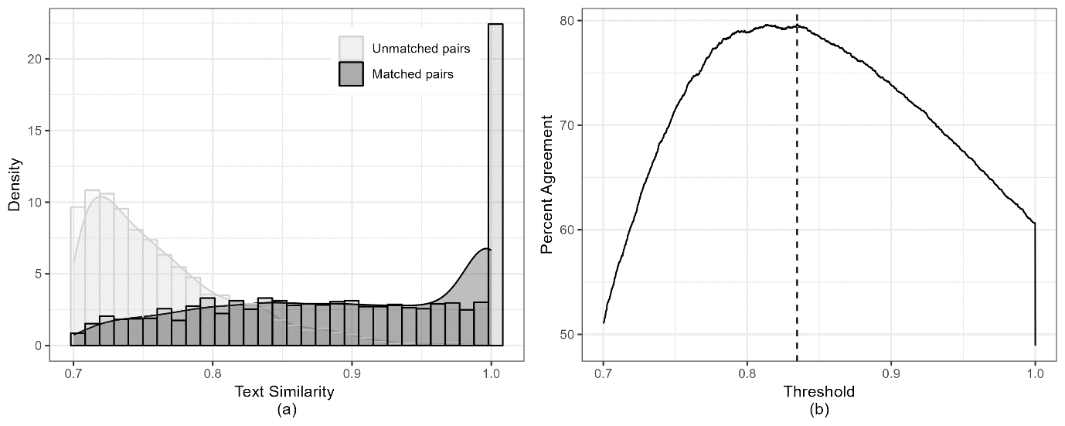

Appendix B

We relied on GPT-4o to classify all trending news topics as either political or non-political categories. Following a governmental-institutional approach (Fitzgerald, 2013), political topics are those related to governmental behaviors, public policies, public affairs or activities of politicians, international relations, war and conflicts, and social events with strong political meanings. In contrast, non-political ones include general social issues (e.g., culture, education, and health), pure entertainment (e.g., pets, fandom, sports), and other politically irrelevant topics. After two rounds of pilot tests, we designed the final prompt, which is presented in Table B1 (both in Chinese and in English).

Table B1 Trending topics on Weibo that also trend on Douyin or Toutiao

Prompt in Chinese | Translation
请仔细阅读以下新闻标题的文字，并参照以下编码标准，将新闻标题分为政治性(1)和非政治性(0)。  编码标准为：政治性内容包含以下几个方面：  - 核心要素： 必须与政府运作、政策制定、公共事务或政党活动直接相关。  - 常见主题： 政府活动（如政策发布、官员讲话）、国际关系（如国家间谈判、国际会议）、政党与政治人物动态（如选举、党内斗争）、具有政治意味的社会议题（如涉及政府政策的社会事件）、国际军事冲突和战争（如涉及军事行动细节、战争死伤等）。  - 排除内容：爱国或软宣传内容，如单纯赞美国家成就、宣传民族自豪感等。  - 健康卫生议题，如疾病防控、食品安全等，即使政府参与其中，也不算入政治类。  - 社会性议题，仅当与政府规定、政策制度、提案相关时才算入政治类，如政府出台的教育政策、医疗改革方案等。若只是政府机关单位回应某个社会性议题，如回应民众对某事件的诉求，则不算入政治类。  非政治类内容是所有不符合政治类内容定义的新闻内容。常见主题： 娱乐八卦、体育赛事、财经新闻（不涉及政策影响）、社会新闻（不涉及政府政策）、科技新闻（不涉及政策影响）等。  如果属于政治性内容，则编码为1；如果不符合编码标准里的任一条内容，则编码为0。不需要提供任何解释。根据以上编码标准，对以下新闻标题进行编码: {headline} | Please carefully read the text of the following news headlines and classify them as political (1) or non-political (0) according to the following coding criteria.  Coding Criteria: Political Content Includes:  - Core Elements: Must be directly related to government operations, policy-making, public affairs, or party activities.  - Common Themes: Government activities (e.g., policy announcements, official speeches), International relations (e.g., negotiations between countries, international summits), Political parties and figures (e.g., elections, internal party struggles), Social issues with political significance (e.g., events involving government policies), International military conflicts and wars (e.g., military operations, war casualties)  - Exclusions: Patriotic or soft propaganda content (e.g., merely praising national achievements, promoting national pride), Health and hygiene topics (e.g., disease prevention, food safety), even if the government is involved, Social issues are only classified as political if related to government regulations, policies, or proposals (e.g., education reforms, healthcare policies). If a government agency merely responds to a public concern, it is not considered political.  Non-Political Content: All news topics that do not fit the definition of political content. Common examples include: Entertainment gossip, sports events, financial news (unless involving policy impact), social news (unless involving government policies), technology news (unless involving policy impact).  If the content is political, code it as 1. If it does not meet any of the political criteria, code it as 0. No explanation is needed. Classify the following news headline according to the criteria: {headline}

The reliability of the GPT-4o model was further assessed through a sample of 1,000 trending topics, which were manually coded by two human coders, achieving a human-GPT agreement rate of 98.2% (Krippendorff’s α = 0.681). Based on this validation, the model was used to assist with classification.

Appendix C

To filter trending topics associated with the Israel-Hamas war, we compiled a comprehensive list of keywords, including: Israel-Palestine (巴以), Israel (以色列), Gaza (加沙), Palestine (巴勒斯坦), Hamas (哈马斯), Israeli forces (以军), Israeli prime minister (以总理), Jerusalem (耶路撒冷), Israel-Palestine (以巴), West Bank conflict (西岸冲突), Netanyahu (内塔尼亚胡), Israeli side (以方), and Palestinian side (巴方).
We further conducted a manual review of all trending topics identified through these keywords. Topics that appeared before the onset of the Israel-Hamas war in October 2023, as well as those unrelated to the conflict (e.g., news about “Palestinian tourists visiting China”) were deemed irrelevant and excluded from subsequent analyses.

Table C1 Trending topics on Weibo that also trend on Douyin or Toutiao

ID | Trending topics (in Chinese & English translation) | Weibo-Douyin | Weibo-Toutiao
1 | 以色列国防军宣布进入战争状态  The Israel Defense Forces declared a state of war. | 1 | 1
2 | 以巴爆发大规模冲突造成严重伤亡  A large-scale conflict between Israel and Palestine has caused severe casualties. | 1 | 1
3 | 巴以冲突双方死亡人数已超400  The death toll on both sides of the Israel-Palestine conflict has exceeded 400. | 1 | 0
4 | 以色列正式向哈马斯宣战  Israel has officially declared war on Hamas. | 1 | 0
5 | 以色列音乐节遇袭至少260死  At least 260 killed in an attack on an Israeli music festival. | 1 | 1
6 | 在以色列华人中至少3人中弹4人失联  Among Chinese nationals in Israel, at least three were shot and four are missing. | 1 | 0
7 | 巴以本轮冲突双方伤亡人数已超6000  The casualties in the current Israel-Palestine conflict have exceeded 6,000. | 1 | 0
8 | 被哈马斯绑架的中以混血女孩父母发声  The parents of a Chinese-Israeli mixed-race girl kidnapped by Hamas speak out. | 1 | 0
9 | 巴以冲突已致超过2300人死亡  The Israel-Palestine conflict has resulted in over 2,300 deaths. | 1 | 0
10 | 以色列空袭叙利亚两座机场  Israel launched airstrikes on two Syrian airports. | 1 | 1
11 | 以色列要求加沙北部上百万人迁移至南部  Israel demands over a million people in northern Gaza to relocate to the south. | 1 | 0
12 | 扎伤以色列外交人员家属的嫌疑人被抓获  The suspect who stabbed an Israeli diplomat’s family member has been arrested. | 1 | 0
13 | 警方通报以色列外交人员家属被扎伤  Police report that an Israeli diplomat’s family member was stabbed. | 1 | 0
14 | 巴以冲突已致中国公民4死6伤2失联  The Israel-Palestine conflict has left 4 Chinese citizens dead, 6 injured, and 2 missing. | 1 | 1
15 | 中国将派特使推动巴以停火止战  China will send a special envoy to promote a ceasefire between Israel and Palestine. | 1 | 0
16 | 以方宣布断绝与联合国中东问题特使关系  Israel announces severing ties with the UN Special Coordinator for the Middle East. | 1 | 1
17 | 以军在加沙边界集结装甲推土机  Israeli forces amass armored bulldozers along the Gaza border. | 1 | 0
18 | 拜登称必须彻底消灭哈马斯  Biden says Hamas must be completely eliminated. | 1 | 0
19 | 中国政府向巴勒斯坦提供紧急人道主义援助  The Chinese government provides emergency humanitarian aid to Palestine. | 1 | 0
20 | 加沙地带一医院遭袭数百人死亡  Hundreds killed in an attack on a hospital in Gaza. | 1 | 1
21 | 拜登抵达以色列  Biden arrives in Israel. | 1 | 0
22 | 拜登抵达以色列之际以近加沙边境响起警报  Sirens sound near the Gaza border as Biden arrives in Israel. | 1 | 0
23 | 巴以冲突已致双方超4900人死亡  The Israel-Palestine conflict has resulted in over 4,900 deaths on both sides. | 1 | 1
24 | 以色列再次空袭叙利亚两座机场  Israel launches another airstrike on two Syrian airports. | 1 | 0
25 | 以色列内阁投票撤销该国公共外交部  The Israeli cabinet votes to dissolve the country’s Public Diplomacy Ministry. | 1 | 1
26 | 以色列要求古特雷斯辞职  Israel calls for Guterres to resign. | 1 | 0
27 | 以军夜间发起一次大规模地面进攻  Israeli forces launch a large-scale nighttime ground offensive. | 1 | 0
28 | 中国代表当场回应以色列不满  Chinese representative responds to Israel’s dissatisfaction on the spot. | 1 | 1
29 | 以色列要求俄罗斯驱逐哈马斯  Israel demands Russia expel Hamas. | 1 | 0
30 | 巴以冲突已超9200人死亡  The Israel-Palestine conflict has exceeded 9,200 deaths. | 1 | 1
31 | 哈马斯持续向以色列发射大量火箭弹  Hamas continues to fire large numbers of rockets at Israel. | 1 | 0
32 | 玻利维亚决定与以色列断交  Bolivia decides to sever diplomatic ties with Israel. | 1 | 0
33 | 法国驻加沙机构遭以色列空袭  Israel strikes a French facility in Gaza. | 1 | 0
34 | 以色列部长声称可对加沙投核弹  An Israeli minister claims a nuclear strike on Gaza is possible. | 1 | 0
35 | 巴勒斯坦总统车队遭袭  The Palestinian president's convoy was attacked. | 1 | 1
36 | 联合国9名人员在以色列空袭中丧生  Nine UN staff members killed in an Israeli airstrike. | 0 | 1
37 | 联合国称以色列可能构成国际犯罪  The UN states Israel may be committing international crimes. | 0 | 1
38 | 以色列炮击黎巴嫩南部地区  Israel shells southern Lebanon. | 0 | 1
39 | 以色列在加沙地带附近集结坦克  Israel deploys tanks near Gaza. | 0 | 1
40 | 加沙孕妇在无麻醉下接受剖腹产  A pregnant woman in Gaza undergoes a C-section without anesthesia. | 0 | 1
41 | 上海一女子到以色列度假遇战乱  A woman from Shanghai was caught in the war while vacationing in Israel. | 0 | 1
42 | 以色列称坚决拒绝停火  Israel firmly rejects a ceasefire. | 0 | 1
43 | 加沙地带一所学校遭袭  A school in Gaza was attacked. | 0 | 1
44 | 美国男子26刀刺死巴勒斯坦裔男孩  A U.S. man stabbed a Palestinian boy 26 times to death. | 0 | 1
45 | 以军称在空袭行动中打死一哈马斯高级领导人  Israeli forces claim to have killed a senior Hamas leader in an airstrike. | 0 | 1
46 | 安吉丽娜朱莉谴责以色列  Angelina Jolie condemns Israel. | 0 | 1
47 | 黎巴嫩以色列临时边界发生交火  Gunfire exchanged at the Lebanon-Israel temporary border. | 0 | 1
48 | 知情人称哈马斯被消灭前以色列不考虑停火  Sources say Israel will not consider a ceasefire until Hamas is eliminated. | 0 | 1
49 | 以色列内阁部长儿子阵亡  The son of an Israeli cabinet minister was killed. | 0 | 1
50 | 加沙医院遭袭20小时前孩子们还在做游戏  Children were playing just 20 hours before a Gaza hospital was attacked. | 0 | 1
51 | 联合国宣布调查巴以冲突中的战争罪行  The UN announces an investigation into war crimes in the Israel-Palestine conflict. | 0 | 1
52 | 拜登讲话用911提醒以色列  Biden invokes 9/11 in a speech to remind Israel. | 0 | 1
53 | 以军称地面部队已包围加沙城  Israeli ground forces claim to have encircled Gaza City. | 0 | 1
54 | 加沙地带停火协议正式生效  A ceasefire agreement in Gaza has officially taken effect. | 0 | 1
55 | 哈马斯发言人等60多人被以色列逮捕  Hamas spokesperson and over 60 others arrested by Israel. | 0 | 1

Appendix D
We conducted a series of supplemental analyses to assess the robustness of our findings. These checks help determine whether the estimated effects persist under different modeling choices, alternative samples, and potential biases. We summarized all the treatment effects in Table D1. Generally, most estimates remain consistent with our main findings. We also observe some insignificant results, which provide valuable evidence regarding the limits of the treatment effect and suggest where it may weaken under specific conditions.
First, we re-estimated the models using 10-minute (A1) and 30-minute (A2) intervals, testing whether the results were sensitive to the granularity of time aggregation. Our results largely hold across different temporal aggregations, but for 30-minute intervals, the discussion metric in Weibo-Douyin trending group is insignificant. This indicates that engagement patterns may be more sensitive to temporal granularity compared to viewership patterns, potentially due to fluctuations in user interaction behavior.
Second, we restricted the sample to topics that remained on the trend list for more than 3 hours (B1) and more than 5 hours (B2). This addresses potential biases from short-lived topics and confirms that the effects hold for topics with sustained popularity. The results show that the treatment effects remain statistically significant. Importantly, the effects slightly weaken in some cases, suggesting a potential boundary condition: treatment effects might be strongest for emerging topics but could dissipate as a topic remains trending for an extended period.
Third, we included additional lags of the dependent variable to better control for autocorrelation and dynamic trends (C). We added another three lagged DVs based on the ACF plots. The discussion patterns in both groups remain stable, but the outcome on viewing of Weibo-Toutiao trending topics becomes insignificant. A possible reason is that the inclusion of additional lags may reveal underlying dynamic trends that were previously unaccounted for, and the Weibo-Toutiao group’s treatment effect may be more sensitive to these trends.
Fourth, we removed all Chinese-government-related news topics created by state media like People’s Daily or CGTN (N = 11). If the observed effects were driven primarily by such topics, we would expect a substantial change in the results. However, Table A4 shows that the key treatment effects remain largely unchanged, reinforcing the idea that our findings are not unduly influenced by state-driven content.
Fifth, we conducted a placebo test by artificially shifting the treatment to a one-hour lagged version to assess whether the observed effects were spurious (E). If the treatment effects were driven by an unrelated time trend or omitted variable bias, the placebo treatment should yield significant results. However, the placebo test results are insignificant across all models. This strengthens our confidence that the observed results may reflect genuine causal relationships.

Table D1 Summary of key coefficients in the robustness checks

 | Weibo-Douyin Trending |  |  | Weibo-Toutiao Trending
 | View | Discussion |  | View | Discussion
A1. 10-min interval | 0.007 | −0.061 * |  | −0.053 *** | −0.143 ***
 | (0.013) | (0.026) |  | (0.013) | (0.026)
A2. 30-min interval | −0.023 | −0.070 |  | −0.050 ^ | −0.106 *
 | (0.027) | (0.043) |  | (0.026) | (0.042)
B1. Above 3-hour sample | −0.028 | −0.072 * |  | −0.051 * | −0.139 ***
 | (0.020) | (0.036) |  | (0.021) | (0.037)
B2. Above 5-hour sample | −0.032 | −0.068 ^ |  | −0.047 * | −0.134 **
 | (0.023) | (0.040) |  | (0.023) | (0.041)
C. More lagged Y | −0.032 | −0.153 *** |  | −0.013 | −0.089 *
 | (0.022) | (0.041) |  | (0.021) | (0.039)
D. China-unrelated sample | −0.034 ^ | −0.067 ^ |  | −0.056 ** | −0.140 ***
 | (0.020) | (0.036) |  | (0.020) | (0.036)
E. Placebo test | 0.003 | −0.046 |  | −0.011 | −0.042
 | (0.018) | (0.031) |  | (0.019) | (0.034)
Note. Unstandardized coefficients with robust standard errors (clustered at the topic level) in parentheses. ^ p < .1, * p < .05, ** p < .01, *** p < .001.

Appendix E
Figure E1 Screenshots of trending topics on Weibo, Douyin, and Toutiao
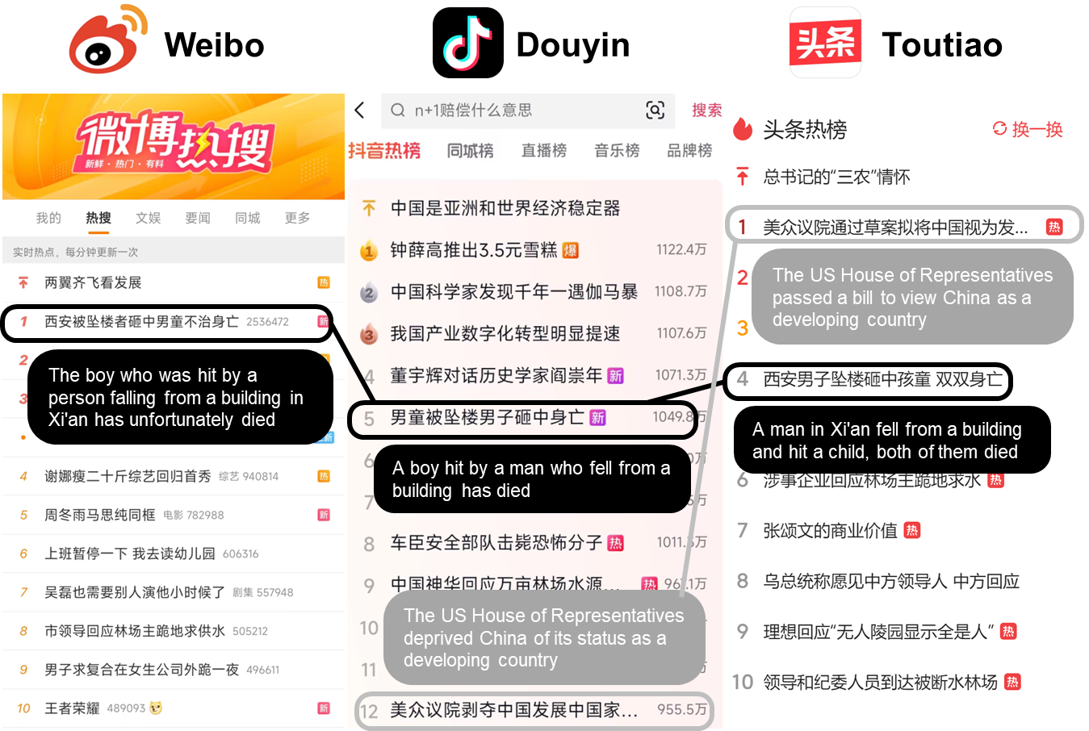

Appendix F

In this part, we measured cross-platform trending by three alternative cutoff values: 0.85, 0.81, 1. Topic pairs that has a higher lexical similarity than each cutoff value was labeled as “cross-platform trending”. We replicated the main findings of Study 1 in Figure F1, Figure F2, Figure F3, respectively. All these results follow the similar patterns to the main findings of Study 1.

Figure F1 Proportions of cross-platform trending by platform and topic type, and Alluvial plots of cross-platform trending topic pairs between three platforms (cutoff = 0.85)

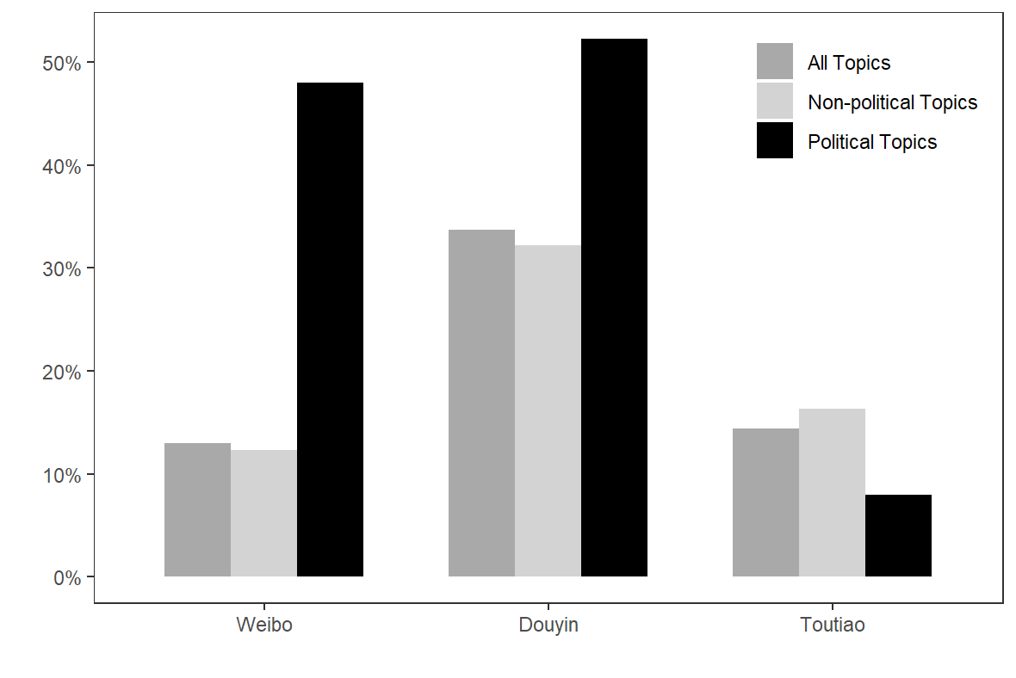
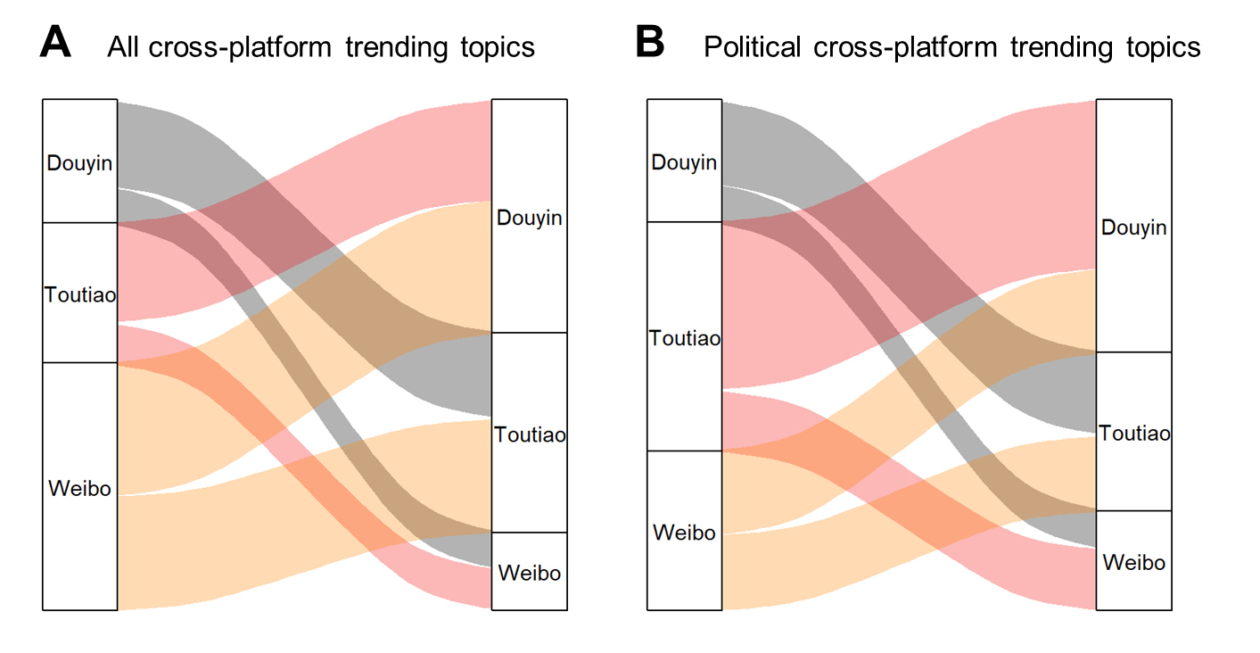

Figure F2 Proportions of cross-platform trending by platform and topic type, and Alluvial plots of cross-platform trending topic pairs between three platforms (cutoff = 0.81)

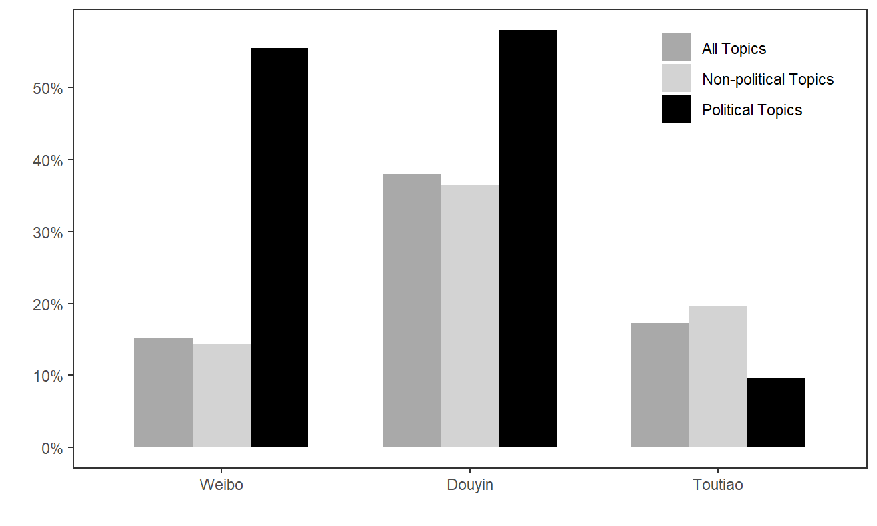
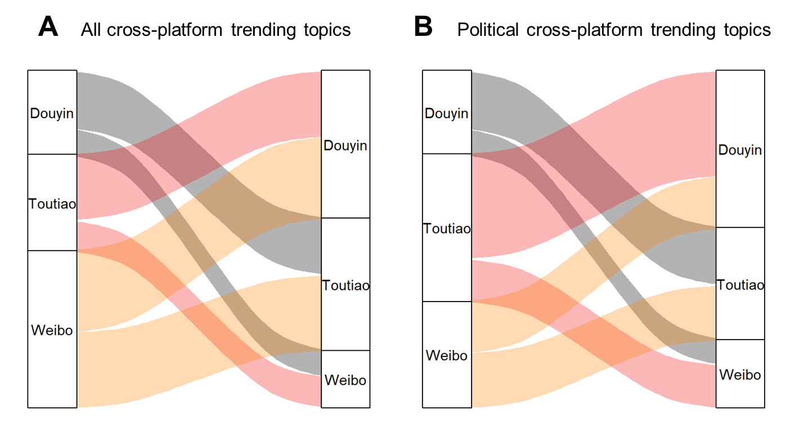

Figure F3 Proportions of cross-platform trending by platform and topic type, and Alluvial plots of cross-platform trending topic pairs between three platforms (cutoff = 1)

