Supplementary Materials

Perceived legitimacy matters: Building public trust and acceptance of AI-generated images in news through strategic AI disclosure

A. Experimental Stimuli and Prompts for Generative Visual AI

B. Pilot Study Results

C. Means and Standard Deviations for Experimental Conditions and Correlation Table

D. Survey Items

E. Results of Moderated Mediation Models (RQ3)

Submitted to Journalism & Mass Communication Quarterly

A. Experimental Stimuli
1. Avalanche × Multiple Victims × Real Photo: https://drive.google.com/file/d/14oHiQqjMeqiKBk8ARgQV7QjaPQlPFMOy/view?usp=drive_link

2. Avalanche × Multiple Victims × Simple Disclaimer: https://drive.google.com/file/d/1M0jPkVtX94t357ofexUF1reRPXTSxFCq/view?usp=drive_link

3. Avalanche × Multiple Victims × External Attribution: https://drive.google.com/file/d/1FhmPkFWwjyXfnsmUPLwMVMKo3fGF5Lje/view?usp=drive_link

4. Avalanche × Multiple Victims × Internal Attribution: https://drive.google.com/file/d/1x0ImXAtpqChKkzdJOOFQkNzSS_Ocfl_O/view?usp=drive_link

5. Avalanche × Single Victim × Real Photo: https://drive.google.com/file/d/1sS80kYEvDTiRmFfobVPX8x5OC5e2A3tQ/view?usp=drive_link

6. Avalanche × Single Victim × Simple Disclaimer:
https://drive.google.com/file/d/1XKPGqkSYGAhrgnS5afs2gD_Y7v-PjEsf/view?usp=drive_link

7. Avalanche × Single Victim × External Attribution: https://drive.google.com/file/d/1brfpVqSdDcvHPrf1oPLGWYEvPjvxTHzy/view?usp=drive_link

8. Avalanche × Single Victim × Internal Attribution: https://drive.google.com/file/d/1l70hn-2C4w0rqP__a8fT4yc1Ghvp_R4u/view?usp=drive_link

9. Volcano Eruption × Multiple Victims × Real Photo: https://drive.google.com/file/d/1xxkdD0FqqoErVYT4Ayoo6pPtg4H5Gt-v/view?usp=drive_link

10. Volcano Eruption × Multiple Victims × Simple Disclaimer: https://drive.google.com/file/d/1Cj-KRswn2W4PwKpcGtJN4Rdiwf50Z3qv/view?usp=drive_link

11. Volcano Eruption × Multiple Victims × External Attribution: https://drive.google.com/file/d/1WZP3xBfBRqlTl38c7R4xVxRl-w5PP4s7/view?usp=drive_link

12. Volcano Eruption × Multiple Victims × Internal Attribution: https://drive.google.com/file/d/1TfRZ0TIw6K_23nF57uOJyw08aA6-t3CV/view?usp=drive_link

13. Volcano Eruption × Single Victim × Real Photo: https://drive.google.com/file/d/1FfYQYLS-C_S-ix9PUkNGIeAUC-fJE2do/view?usp=drive_link

14. Volcano Eruption × Single Victim × Simple Disclaimer: https://drive.google.com/file/d/1WL3KZmDAQpIkQWexgvsDQslWjQkhlRQm/view?usp=drive_link

15. Volcano Eruption × Single Victim × External Attribution: https://drive.google.com/file/d/1p3-0-c7MZXnWdcZfcBTcV0ggp31HccqR/view?usp=drive_link

16. Volcano Eruption × Single Victim × Internal Attribution: https://drive.google.com/file/d/17ASFVaE0fZ-6fr6a7v63Wx9qTyQhI4Cj/view?usp=drive_link

Prompts for Sora (Disaster context: avalanche)
Multiple victims
A breaking news image of a massive avalanche in the remote Alaskan backcountry near Girdwood. Depict five backcountry skiers on a steep, snow-covered slope, with at least two skiers positioned closer to the camera to create a balanced focal point. All skiers should have identifiable, clearly visible faces and fearful emotions, shown in mid-motion as they flee or react naturally and urgently to the approaching avalanche. Do not include the breaking news banner on the picture. The skiers should be wearing bright-colored winter gear (e.g., red or orange jackets) to contrast against the snow, and none should be looking directly at the camera. Include realistic scattered ski equipment—skis, poles, and packs—disrupted across the avalanche path. The surrounding environment should emphasize a vast, cold, overcast mountain landscape, conveying danger, isolation, and tension without dramatization. The recently collapsed snowpack should dominate the left side of the image, emphasizing the avalanche’s severity and scale.

Single victim (ask Sora to revise the image based on the image depicting multiple victims)
Keep the right first person and remove the other persons from the image. Do not alter his composition, size, perspective, or facial expression; keep his pose and placement exactly as if he were originally part of a group image. The aspect ratio of this image should be 3:2.

Prompts for Sora (Disaster context: volcanic eruptions)
Multiple victims
A breaking news image of an active volcanic eruption near the Kīlauea summit on Hawaii’s Big Island. Depict five American tourists scattered at different distances across a rugged, volcanic slope, with at least two tourists positioned closer to the camera to create a balanced focal point, some in the distant midground and background, others slightly closer but still relatively small in the overall frame. All tourists should have identifiable, clearly visible faces and fearful emotions, shown in mid-motion as they flee or react naturally and urgently to the volcanic eruptions. Do not include the breaking news banner on the picture. The victims should wear ash-stained casual clothing (e.g., t-shirts, shorts, hiking gear), with a few partially obscured by smoke, debris, or terrain. The scene should include dramatic ash clouds, black smoke plumes, and flowing molten lava in the background. Incorporate falling debris, scattered backpacks, and a damaged crater overlook to suggest a chaotic escape attempt. The environment should depict tropical volcanic terrain with low visibility and a thick, smoky atmosphere, emphasizing the volcano's severity and scale.

Single victim (ask Sora to revise the image based on the image depicting multiple victims)
Keep the left first person and remove the other persons from the image. Do not alter his composition, size, perspective, or facial expression; Keep his pose and placement exactly as if he were originally part of a group image. The aspect ratio of this image should be 3:2.

B. Pilot Study Results
We conducted a pilot study to identify the most appropriate justifications for AI use that align with participants’ perceptions of external and internal attributions. Specifically, we aimed to determine which reasons for using AI-generated images in disaster news coverage were seen as more altruistic (external) or self-serving (internal).
First, we developed five potential justifications for using AI-generated images: 1) The disaster site was physically inaccessible, so the newsroom used AI to illustrate the scene. 2) The newsroom used AI-generated imagery to enhance visual appeal and increase reader engagement. 3) To avoid placing journalists in dangerous conditions, the newsroom opted for AI-generated images rather than sending reporters to the scene. 4) To protect the dignity and privacy of disaster victims and their families, the newsroom used AI-generated images instead of real photographs. 5) The newsroom used AI-generated images to reduce expenses on travel and on-the-ground photography.
Next, we recruited 100 participants via Prolific. Each participant was randomly shown either an AI-generated image of an avalanche or a volcanic eruption. After viewing the image, they were presented with the five justifications one at a time. For each reason, participants rated two dimensions: 1) Perceived legitimacy, measured on a 5-point Likert scale (e.g., “Given the above reason, I believe the use of the AI-generated image is legitimate / justifiable / appropriate / aligned with professional journalistic norms / ethical / in compliance with relevant policies / reasonable”). 2) Perceived self-serving intention, rated on a 5-point scale (1 = entirely altruistic, 5 = mostly self-serving).
To identify the most externally and internally attributed justifications, we compared the mean ratings across conditions. As shown in Figure B1, “protecting the victim’s privacy” was perceived as the most legitimate reason (M = 3.40), while “cost-saving” was rated the least legitimate (M = 2.58). A paired t-test confirmed this difference was statistically significant (t = 4.73, p < .001).
Similarly, as shown in Figure B2, participants rated “protecting the victim’s privacy” as the least self-serving justification (M = 2.36), whereas “cost-saving” was viewed as the most self-serving (M = 4.03), with a significant difference between the two (t = –10.05, p < .001).
These findings align with prior literature on attribution theory (Jahn et al., 2020), which shows that internal attributions are typically associated with higher perceived self-serving intent and lower legitimacy, whereas external attributions are linked to lower perceived self-interest and higher legitimacy. Based on these results, we selected “protecting the victim’s privacy” as the external attribution and “cost-saving” as the internal attribution justification for use in the main study.

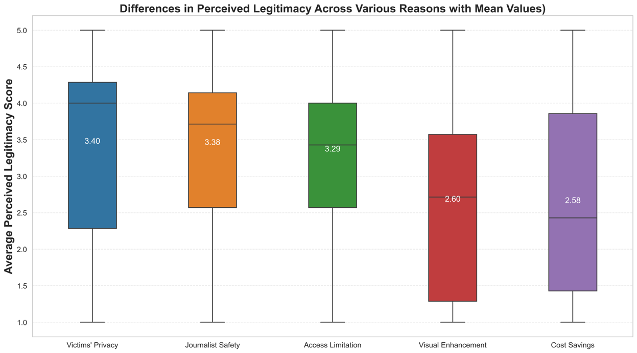
Figure B1. Differences in perceived legitimacy across five reasons with mean values.

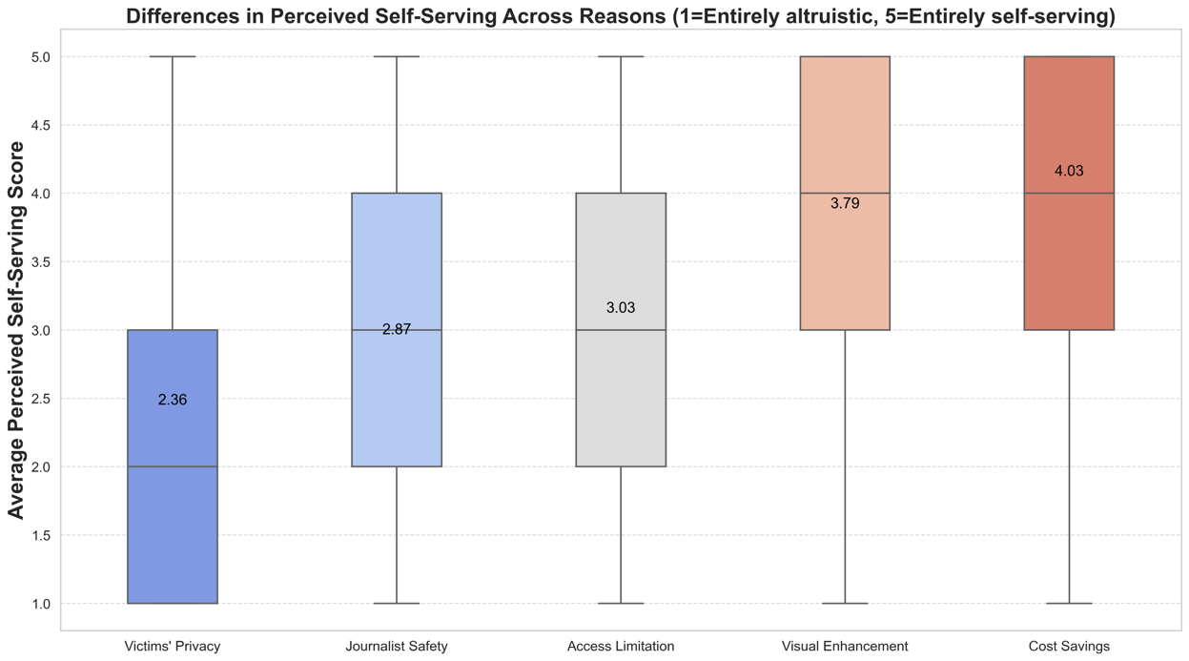
Figure B2. Differences in perceived self-serving intention across five reasons with mean values.

C. Means and Standard Deviations for Experimental Conditions and Correlation Table
We displayed the means and standard deviations (in parentheses) for all experimental conditions in Table C1. Pearson’s correlations among all measured variables, namely, perceived legitimacy, trust in the news organization, acceptance of AI in journalism, and attitudes toward AI, are included in Table C2.

Table C1. Means and standard deviations (in parentheses) for all experimental conditions.
Experimental Condition | Perceived Legitimacy | Trust in the News Organization | Acceptance of AI in Journalism | Attitudes toward AI
Disaster Context: Avalanche
Multiple Victims × Real Photo (N=77) | 4.00 (0.77) | 3.38 (0.96) | 3.00 (1.26) | 3.62 (1.05)
Multiple Victims × Disclaimer (N=74) | 2.83 (1.21) | 2.70 (1.03) | 2.59 (1.22) | 3.40 (0.95)
Multiple Victims × External (N=71) | 3.13 (1.17) | 2.79 (1.08) | 2.75 (1.29) | 3.43 (1.06)
Multiple Victims × Internal (N=91) | 2.92 (1.23) | 2.76 (1.06) | 2.76 (1.35) | 3.48 (1.01)
Single Victim × Real Photo (N=69) | 4.1 (0.63) | 3.38 (0.97) | 2.89 (1.19) | 3.43 (1.07)
Single Victim × Disclaimer (N=69) | 2.87 (1.31) | 2.87 (1.19) | 2.53 (1.36) | 3.40 (1.06)
Single Victim × External (N=64) | 3.03 (1.18) | 2.94 (0.91) | 2.70 (1.17) | 3.45 (0.95)
Single Victim × Internal (N=69) | 2.98 (1.2) | 2.74 (1.13) | 2.81 (1.29) | 3.48 (1.05)
Disaster Context: Volcano Eruptions
Multiple Victims × Real Photo (N=69) | 3.88 (0.7) | 3.28 (0.87) | 2.90 (1.17) | 3.42 (0.97)
Multiple Victims × Disclaimer (N=73) | 2.61 (1.17) | 2.55 (1.12) | 2.53 (1.24) | 3.16 (0.93)
Multiple Victims × External (N=75) | 2.85 (1.26) | 2.68 (1.22) | 2.85 (1.43) | 3.38 (1.13)
Multiple Victims × Internal (N=69) | 2.76 (1.21) | 2.74 (1.13) | 2.77 (1.24) | 3.73 (0.91)
Single Victim × Real Photo (N=62) | 4.03 (0.79) | 3.32 (0.74) | 2.92 (1.23) | 3.58 (1.04)
Single Victim × Disclaimer (N=84) | 2.80 (1.13) | 2.60 (1.22) | 2.69 (1.29) | 3.45 (0.93)
Single Victim × External (N=77) | 3.20 (1.22) | 2.90 (1.17) | 2.92 (1.31) | 3.50 (1.01)
Single Victim × Internal (N=78) | 2.75 (1.11) | 2.46 (0.99) | 2.63 (1.21) | 3.44 (1.06)

Table C2. Pearson’s correlations among all measured variables.
Variable | Perceived Legitimacy | Trust in the News Organization | Acceptance of AI in Journalism | Attitudes toward AI
Perceived Legitimacy |  | 0.64*** | 0.63*** | 0.28***
Trust in the News Organization | 0.64*** |  | 0.48*** | 0.28***
Acceptance of AI in Journalism | 0.63*** | 0.48*** |  | 0.44***
Attitudes toward AI | 0.28*** | 0.28*** | 0.44***

D. Survey Items
Attitude toward AI (Grassini, 2023)
Please rate your degree of agreement with the following statements, from 1 (strongly disagree) to 5 (strongly agree).
- I am excited about the potential benefits of AI.
- AI will improve our quality of life.
- I feel uneasy about how AI is being integrated into society.
- AI is likely to do more harm than good in the long run.

Perceived Legitimacy of News Image Usage (Martin & Waldman, 2023)
Please indicate how much you agree or disagree with the following statements. (1 = Strongly Disagree; 5 = Strongly Agree)
- I think the use of the image in the news article is legitimate.
- I think the use of the image in the news article is justifiable.
- I think the use of the image in the news article is appropriate.
- I think the use of the image in the news article is ethical.
- I think the use of the image in the news article is reasonable.
- I think the use of the image complies with relevant policies and laws.
- I think the use of the image aligns with professional journalistic norms.

Trust in the News Organizations (Toff & Simon, 2024)
- How trustworthy would you say the news organization that published this news article is?
Not at all trustworthy 1 2 3 4 5 Completely trustworthy

Acceptance of AI in Journalism
Please rate your degree of agreement with the following statements, from 1 (strongly disagree) to 5 (strongly agree).
- It is acceptable to have AI illustrate disasters in news coverage.
- It is acceptable to have AI depict disaster victims in news coverage.
- It is acceptable to have AI generate news images in the early stages of natural disasters.
- It is acceptable to have AI assist journalists in the early stages of natural disasters.
E. Results of Moderated Mediation Models (RQ3)
To answer RQ3 (“Do people’s attitudes toward AI moderate the indirect effects of disclosure strategies on trust in news organizations and acceptance of AI in journalism via perceived legitimacy?”), we used PROCESS Model 7 in SPSS with multi-categorical antecedent variables (dummy-coded), 5,000 bootstrap resamples, and 95% confidence intervals. Attitudes toward AI were modeled as a continuous moderator of the indirect effects of disclosure strategies (IV) on trust or AI acceptance (DV) via perceived legitimacy (mediator). Disaster context and victim count were incorporated as covariates in the moderated mediation models. The results were shown in Table E1.

Table E1. Conditional indirect effects of AI disclosure strategies on trust in the news organization and acceptance of AI in journalism via perceived legitimacy at different levels of attitudes toward AI.
Outcome variable | Reference groupw | Predictor | Attitudes toward AI | Indirect effect (Boot SE) | 95% CI
Trust in the news organization | Control | Simple disclaimer | −1 SD | −0.862 (0.074) | [−1.009, −0.719]
Trust in the news organization | Control | Simple disclaimer | Mean | −0.700 (0.0563) | [−0.811, −0.591]
Trust in the news organization | Control | Simple disclaimer | +1 SD | −0.538 (0.078) | [−0.690, −0.387]
Trust in the news organization | Control | External attribution | −1 SD | −0.824 (0.070) | [−0.965, −0.687]
Trust in the news organization | Control | External attribution | Mean | −0.551 (0.051) | [−0.650, −0.452]
Trust in the news organization | Control | External attribution | +1 SD | −0.278 (0.070) | [−0.418, −0.141]
Trust in the news organization | Control | Internal attribution | −1 SD | −0.906  (0.073) | [−1.052, −0.764]
Trust in the news organization | Control | Internal attribution | Mean | −0.689 (0.054) | [−0.796, −0.585]
Trust in the news organization | Control | Internal attribution | +1 SD | −0.472 (0.071) | [−0.612, −0.335]
Trust in the news organization | Disclaimer | External attribution (non-significant index) | −1 SD | 0.039 (0.076) | [−0.109, 0.184]
Trust in the news organization | Disclaimer | External attribution (non-significant index) | Mean | 0.149 (0.055) | [0.042, 0.257]
Trust in the news organization | Disclaimer | External attribution (non-significant index) | +1 SD | 0.260 (0.083) | [0.096, 0.425]
Trust in the news organization | Disclaimer | Internal attribution (non-significant index) | −1 SD | −0.04 (0.075) | [−0.194, 0.104]
Trust in the news organization | Disclaimer | Internal attribution (non-significant index) | Mean | 0.011 (0.053) | [−0.094, 0.117]
Trust in the news organization | Disclaimer | Internal attribution (non-significant index) | +1 SD | 0.066 (0.082) | [−0.099, 0.225]
Trust in the news organization | Internal attribution | External attribution (non-significant index) | −1 SD | 0.083 (0.077) | [−0.067, 0.237]
Trust in the news organization | Internal attribution | External attribution (non-significant index) | Mean | 0.138 (0.055) | [0.032, 0.245]
Trust in the news organization | Internal attribution | External attribution (non-significant index) | +1 SD | 0.194 (0.078) | [0.040, 0.347]
Acceptance of AI in journalism | Control | Simple disclaimer | −1 SD | −1.086 (0.089) | [−1.257, −0.914]
Acceptance of AI in journalism | Control | Simple disclaimer | Mean | −0.882 (0.066) | [−1.011, −0752]
Acceptance of AI in journalism | Control | Simple disclaimer | +1 SD | −0.678 (0.095) | [−0.861, −0.491]
Acceptance of AI in journalism | Control | External attribution | −1 SD | −1.037  (0.086) | [−1.204, −0.869]
Acceptance of AI in journalism | Control | External attribution | Mean | −0.694 (0.064) | [−0.818, −0.570]
Acceptance of AI in journalism | Control | External attribution | +1 SD | −0.351 (0.088) | [−0.528, −0.183]
Acceptance of AI in journalism | Control | Internal attribution | −1 SD | −1.141 (0.088) | [−1.314, −0.967]
Acceptance of AI in journalism | Control | Internal attribution | Mean | −0.868 (0.065) | [−0.995, −0.743]
Acceptance of AI in journalism | Control | Internal attribution | +1 SD | −0.595 (0.089) | [−0.769, −0.421]
Acceptance of AI in journalism | Disclaimer | External attribution | −1 SD | 0.049  (0.097) | [−0.146, 0.236]
Acceptance of AI in journalism | Disclaimer | External attribution | Mean | 0.188  (0.070) | [0.050, 0.322]
Acceptance of AI in journalism | Disclaimer | External attribution | +1 SD | 0.327  (0103) | [0.128, 0.525]
Acceptance of AI in journalism | Disclaimer | Internal attribution (non-significant index) | −1 SD | −0.055 (0.096) | [−0.245, 0.129]
Acceptance of AI in journalism | Disclaimer | Internal attribution (non-significant index) | Mean | 0.014  (0.070) | [−0.127, 0.151]
Acceptance of AI in journalism | Disclaimer | Internal attribution (non-significant index) | +1 SD | 0.083  (0.107) | [−0.133, 0.292]
Acceptance of AI in journalism | Internal attribution | External attribution  (non-significant index) | −1 SD | 0.104 (0.095) | [−0.083, 0.293]
Acceptance of AI in journalism | Internal attribution | External attribution  (non-significant index) | Mean | 0.174  (0.067) | [0.043, 0.306]
Acceptance of AI in journalism | Internal attribution | External attribution  (non-significant index) | +1 SD | 0.244 (0.098) | [0.053, 0436]

Supplementary Materials Reference

Grassini, S. (2023). Development and validation of the AI attitude scale (AIAS-4): A brief measure of general attitude toward artificial intelligence. Frontiers in Psychology, 14. https://doi.org/10.3389/fpsyg.2023.1191628
Martin, K., & Waldman, A. (2023). Are Algorithmic Decisions Legitimate? The Effect of Process and Outcomes on Perceptions of Legitimacy of AI Decisions. Journal of Business Ethics, 183(3), 653–670. https://doi.org/10.1007/s10551-021-05032-7
Toff, B., & Simon, F. M. (2024). “Or They Could Just Not Use It?”: The Dilemma of AI Disclosure for Audience Trust in News. The International Journal of Press/Politics, 19401612241308697. https://doi.org/10.1177/19401612241308697

